How Substance Abuse Contributed to the Decline in US Life Expectancy from 2016-2021

Abstract:
Life expectancy in the US dropped precipitously in 2020 and 2021. At first glance this pattern seems pandemic-related, but life expectancy was already trending downwards as early as 2016 and actuarial data from the Social Security administration is inconsistent with reports of a respiratory infection that was culling the elderly. Even during the deadliest year (2021), the death rate for ages 65-74 never exceeded 20% over their lowest point in 2019. In sharp contrast, the death rate for ages 30-39 nearly doubled over its lowest point in 2010. This sharp rise in death rate for ages 30-39 coincides with a sharp rise in overdose deaths that centers on this age group, and in 2020, deaths attributed to COVID-19 made up only 30% of excess death for ages 30-30, and three times more Americans in this age group died from substance abuse than from the virus. In sharp contrast, deaths attributed to COVID-19 made up the entirety of excess deaths for ages 65-74, and a demographic shift from 2010-2020 that increased the population of ages 65-74 by 40-55% greatly increased the ratio of Americans more likely to die from respiratory infections.

Introduction:
Over the last century there were two significant declines in life expectancy that coincided with reports of a worldwide pandemic (Fig. 1), but the role of SARS-CoV-2 in the more recent decline is disputed because life expectancy had already been trending downwards four years before the coronavirus reportedly made its way into the US (Fig. 2) [1,2]. What was happening in America prior to the reports of a novel virus?

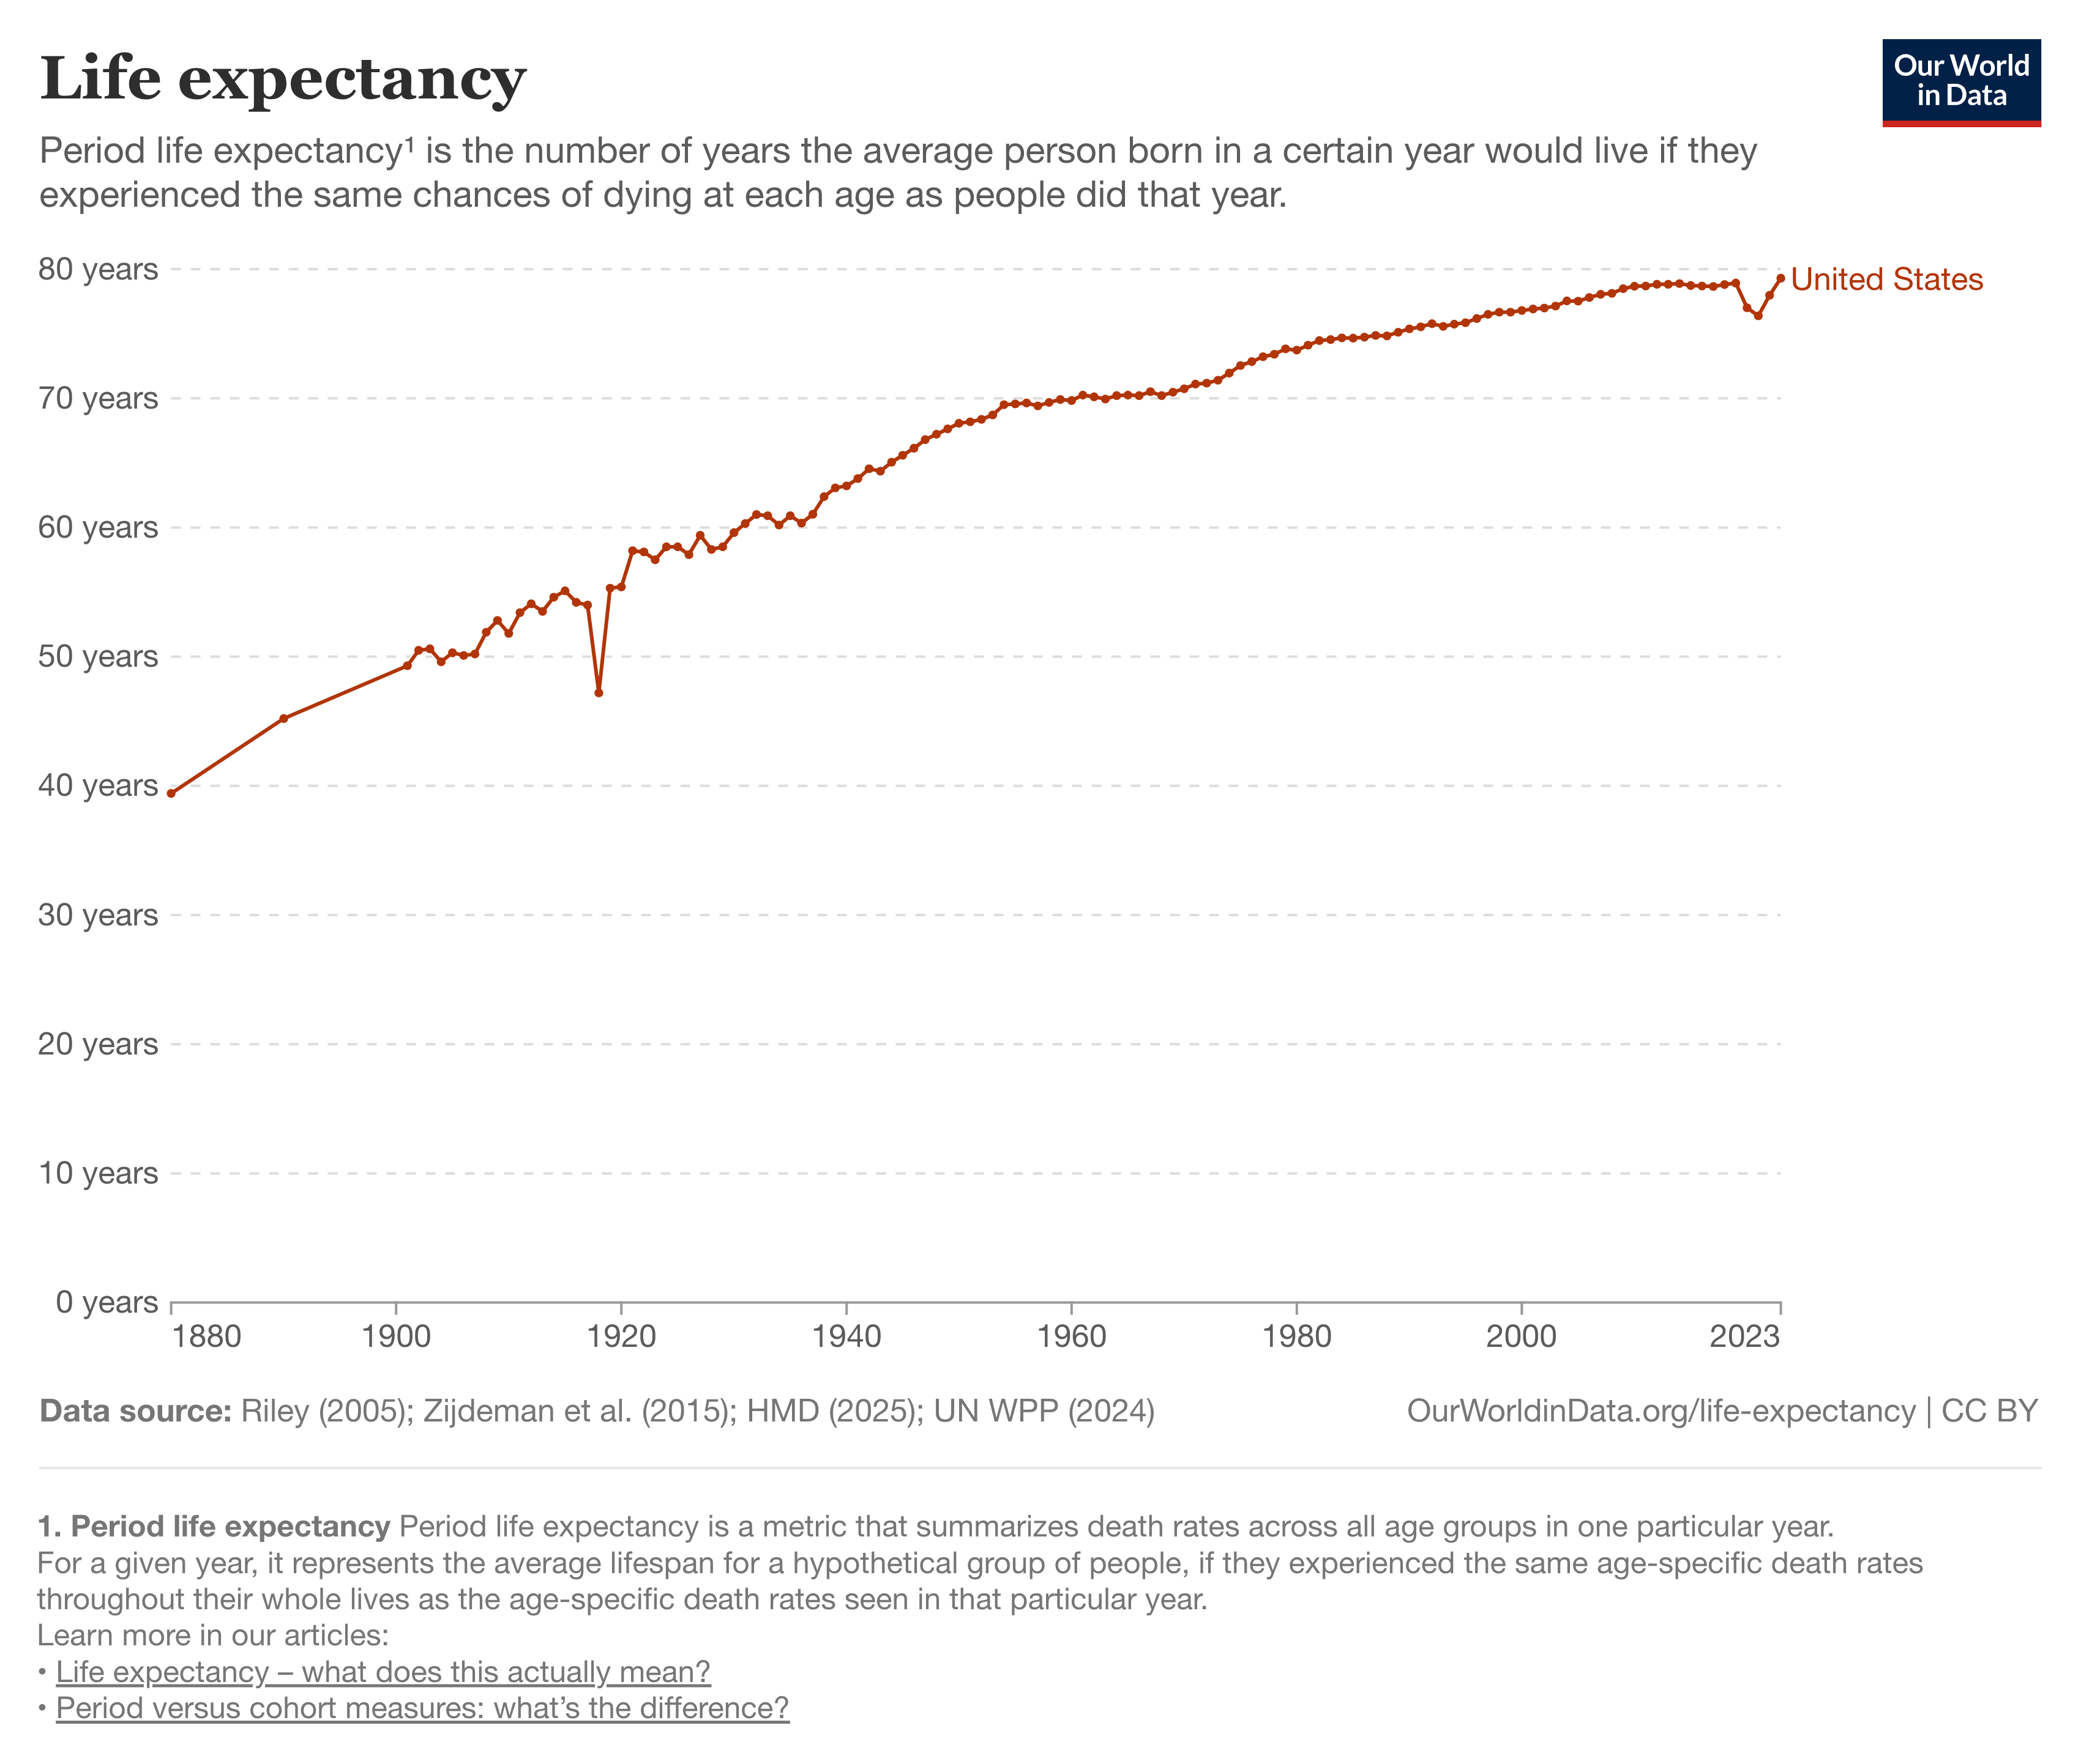
Fig. 1: Graph retrieved from “Life Expectancy” Published online at OurWorldinData.org [1].

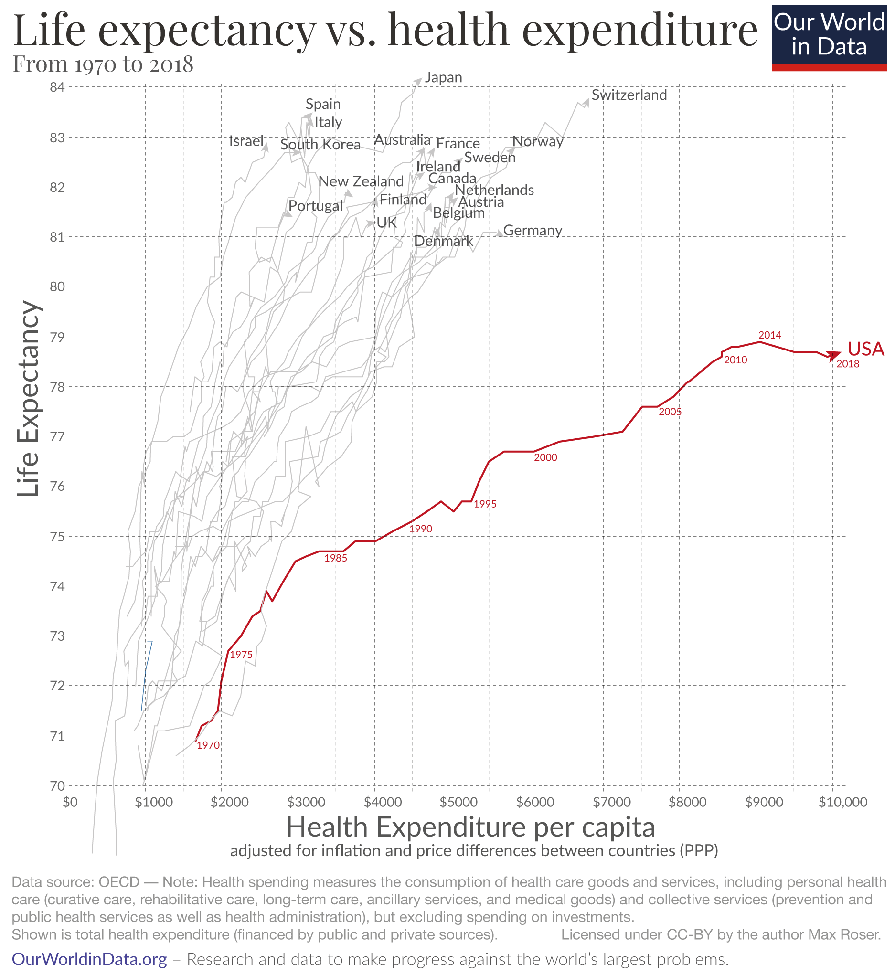
Fig. 2: Graph retrieved from “Why is life expectancy in the US lower than in other rich countries?” Published online at OurWorldinData.org [1].

Methods:
All data used in the charts was taken from the websites of governmental and nongovernmental sources that are accessible to the public. These include the Social Security Administration (death rates by age), Our World in Data (total deaths and death rates in 10-year age cohorts), USA Facts (population in 10-year age cohorts). Global Statistics (deaths from COVID-19 in 10-year age cohorts), the Centers for Disease Control and Prevention (death rates from drugs or alcohol organized by age cohort).

Results:
Actuarial data collected by the Social Security Administration indicates that this drop in life expectancy was driven largely by a massive surge in the death rates of both men and women between the ages of 25-42 after 2010 (Fig. 3A, 3B, and 4). These rates were noticeably trending upwards in 2014 and eventually exceeded 90% in the same year overall life expectancy reached its lowest point in Graph 1. In sharp contrast, the death for ages 70 and older never exceeded 20% over its lowest point in 2019 (Fig. 3A, 3B). How do we reconcile this discrepancy with reports on a pandemic that disproportionately affected the elderly?

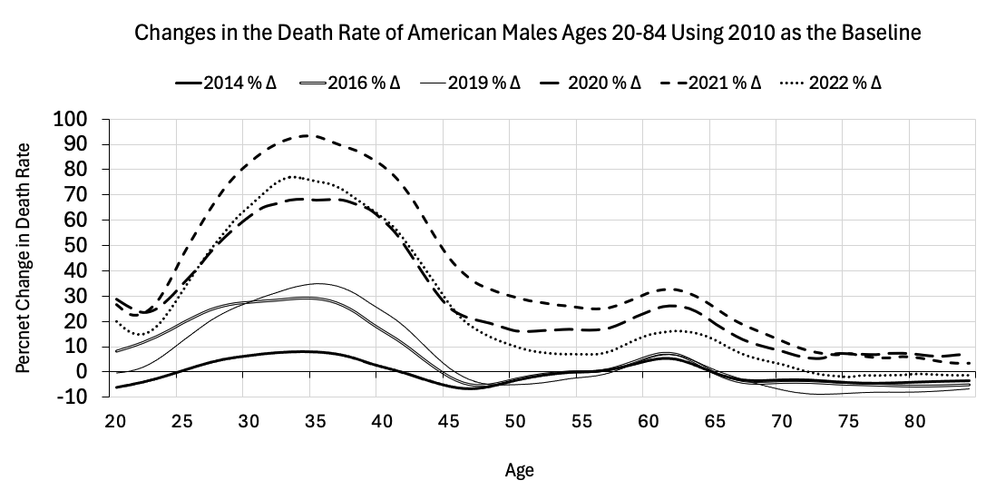
Fig. 3A: Graph generated from data downloaded from the Actuarial Life Table of the US Social Security Administration [3].

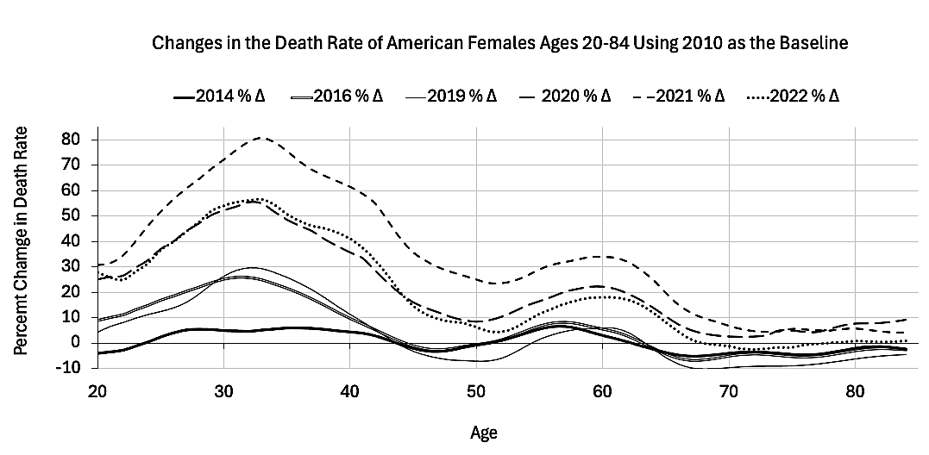
Fig. 3B: Graph generated from data downloaded from the Actuarial Life Table of the US Social Security Administration [3].

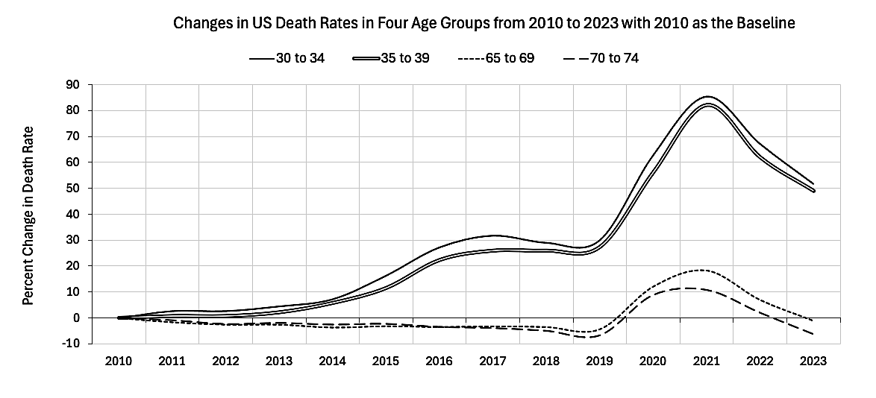
Fig. 4: Graph generated from data downloaded from “Annual Death Rates by Age Group” Published online at OurWorldinData.org [4].

Between 2010 and 2020 a massive surge in the population of aging boomers disproportionately changed the ratio of Americans more likely to die from respiratory infections (Fig. 5). This was predicted, and in 2017 the US Census publicly expressed these concerns over this anticipated rise in all-cause mortality [5]. Hence, with or without a novel virus hospitals and hospices would still have been challenged by this “epidemic” of aging boomers, and prior to the pandemic it was not out of the ordinary for 50,000 Americans to die during flu season [6].

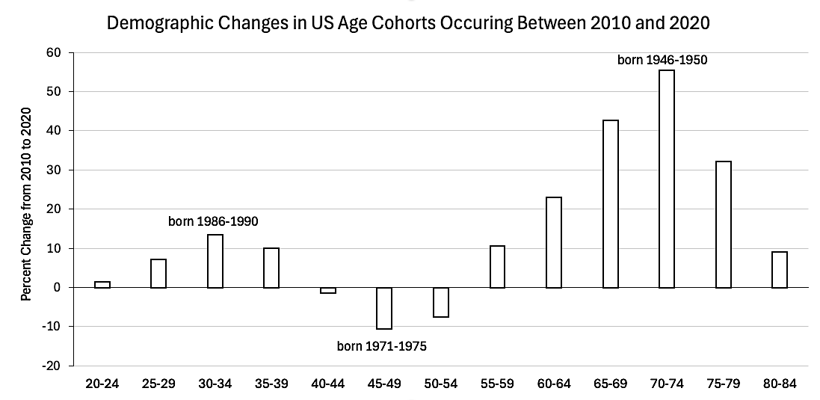
Fig. 5: This graph was generated from data compiled from Our Changing Population: US. Published online at USA Facts [7].

If we graph percent change in total deaths by age group, we get a bimodal distribution with peaks for age groups 30-34 and 70-74 (Fig. 6). For the older age groups (right), the increase in total deaths is driven largely by demographics (white bars in Fig. 6). For the younger age groups (left), the increase in total deaths is driven largely by the increase in death rate (light grey bars in Fig. 6).

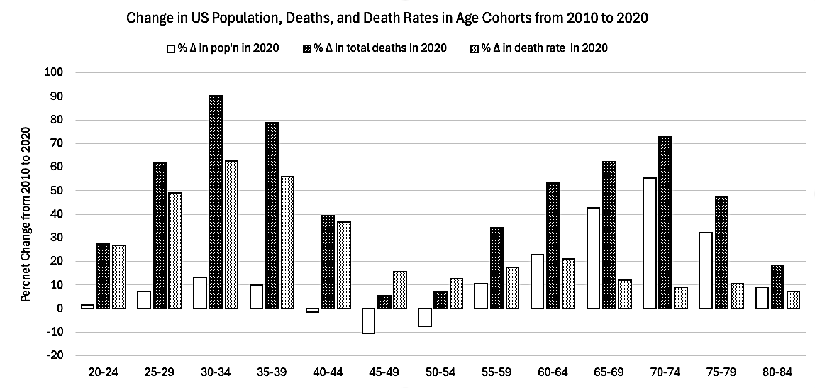
Fig. 6: This graph was generated from data downloaded from “Annual Death Rates by Age Group” at OurWorldinData.org [4], “Our Changing Population: US” at USA Facts [7], and “Annual deaths by age group, United States” at Our World in Data [8].

If we compare deaths from COVID-19 to excess deaths, COVID deaths for ages 30-39 make up only 30% of excess deaths in this age group (Fig. 7). Since younger people in the US are less likely to die from respiratory infections this difference comes to no surprise. In sharp contrast, deaths from COVID-19 make up the entirety of excess deaths for ages 65-74, but a 20% increase in death rates for ages 65-74 has a much lesser effect on life expectancy than an 80-90% spike in death rates for ages 30-39. Why did younger Americans die at such high rates during the years of the pandemic?

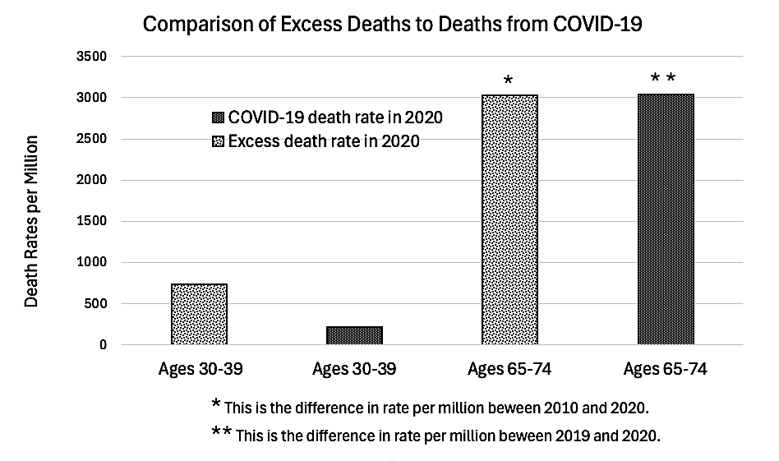
Fig. 7: This graph was generated from data downloaded from “Our Changing Population: US” at USA Facts [7], “Annual deaths by age group, United States” at Our World in Data [8], and “COVID Deaths by Year | Statistics & Facts” at theglobalstatistics.com [9].

In comparison to other affluent nations the US has made very little progress in combating premature death from obesity, homicide, and road injuries, but the only indicator consistently trended upwards from 2000 to 2021 was drug overdose (Fig. 8) [2]. Additional information from the CDC on the age distribution of opioid victims and availability of synthetic opioids leaves little doubt as to their on US life expectancy (Fig. 9 and 10A) [10]. Opioids made up 75% of the overdose deaths in 2021 and 82% of these opioids were synthetically manufactured [11].

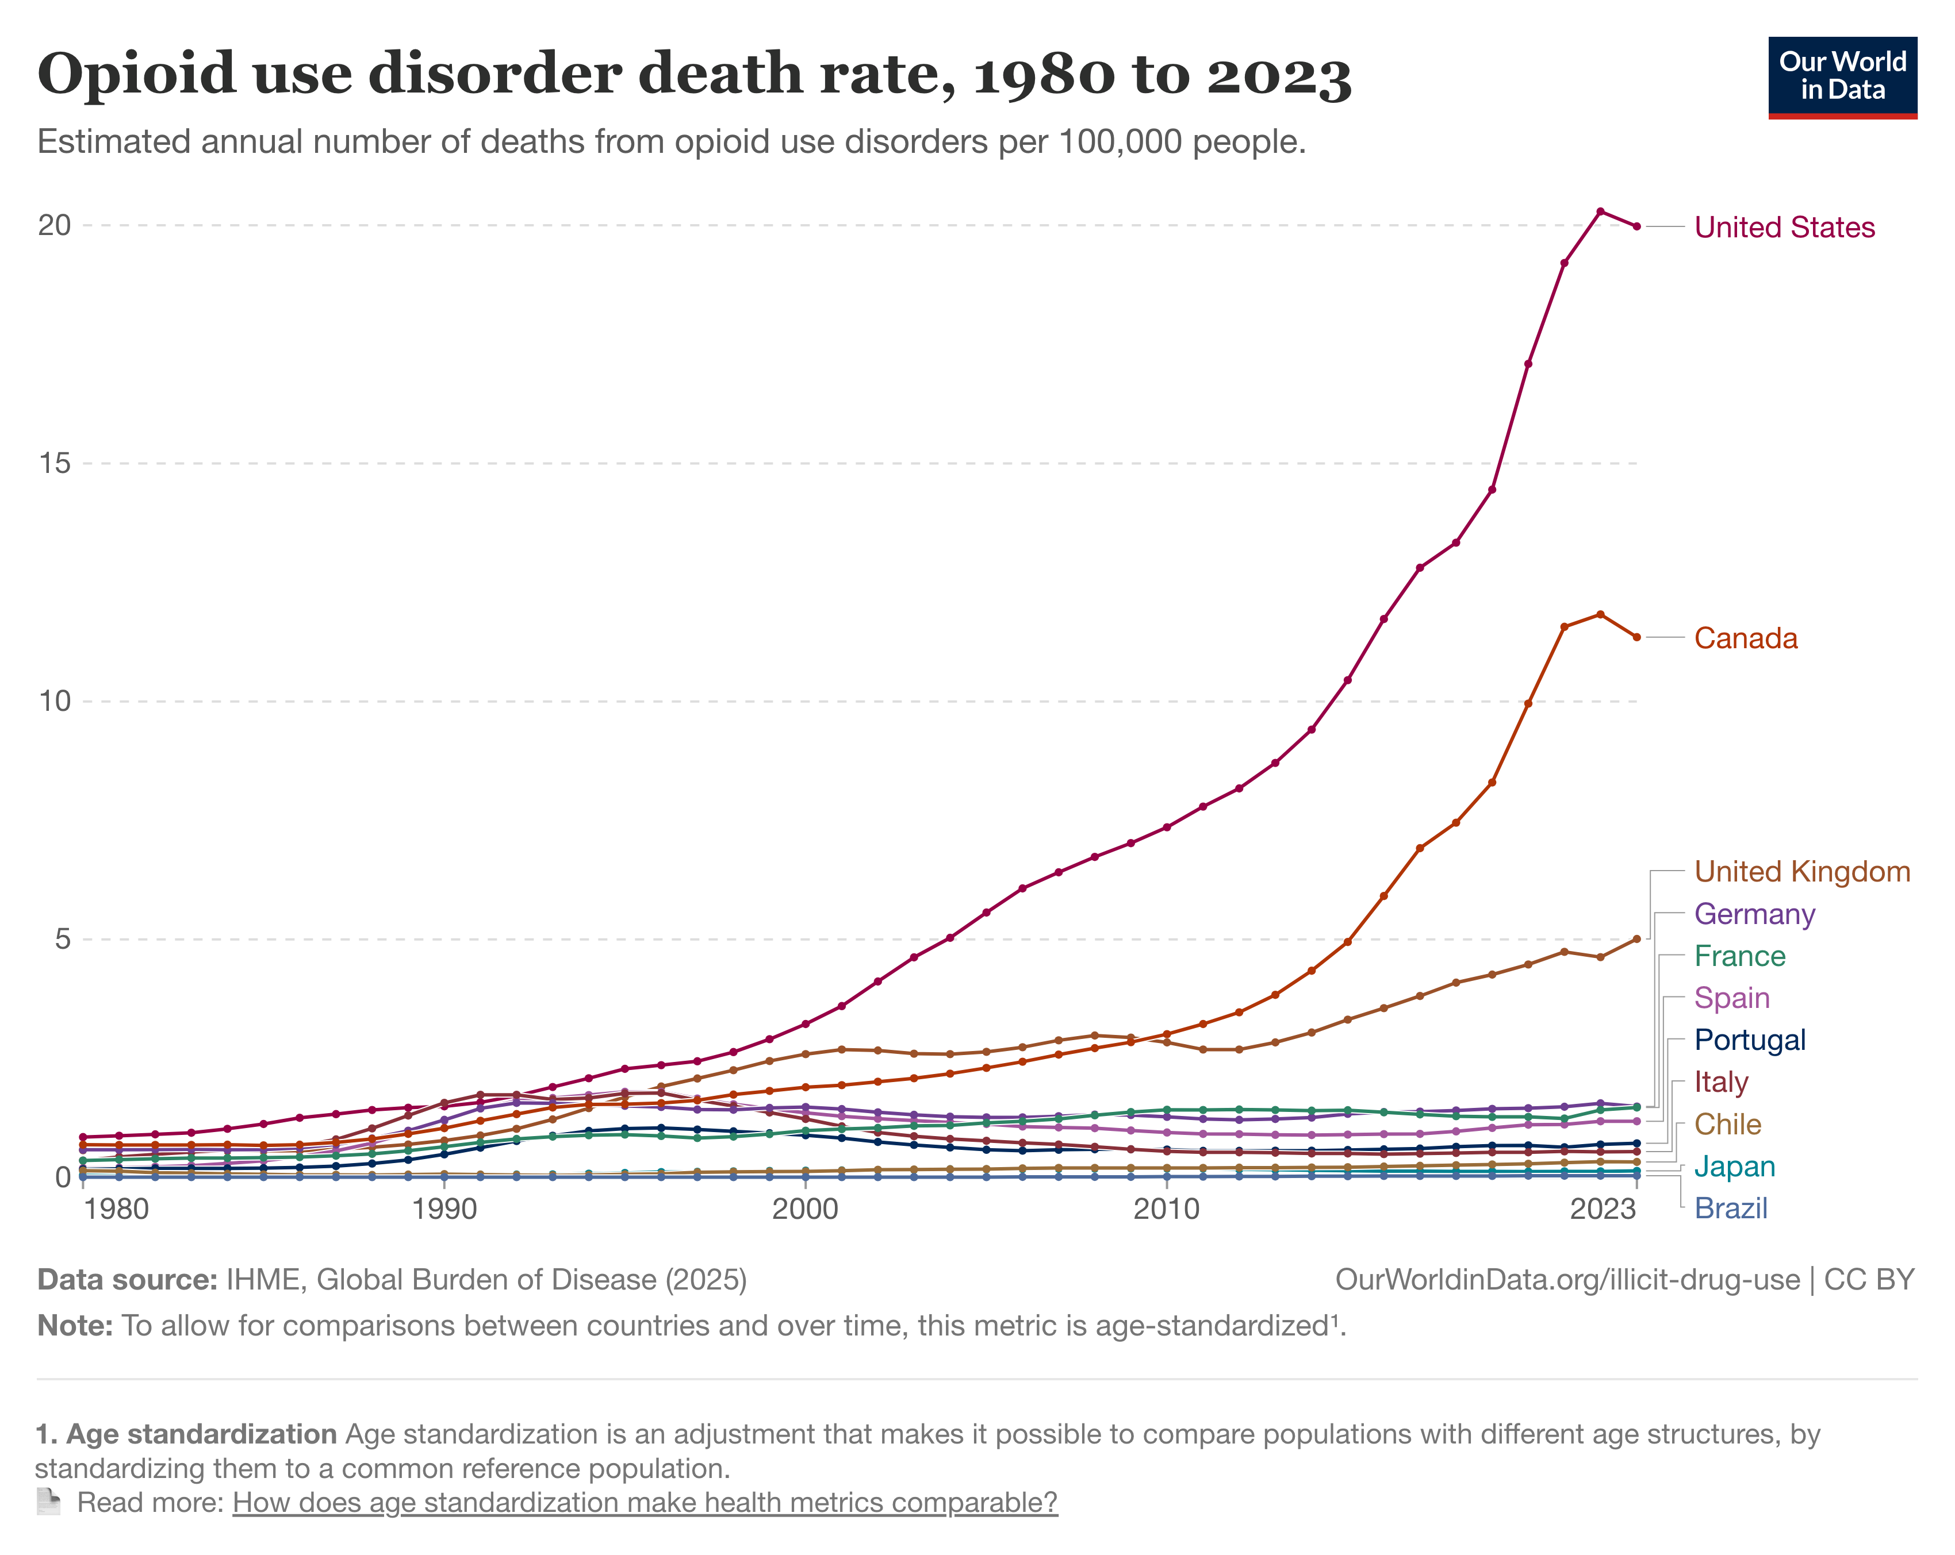
Fig. 8: Graph retrieved from “Why is life expectancy in the US lower than in other rich countries?” Published online at OurWorldinData.org [1].

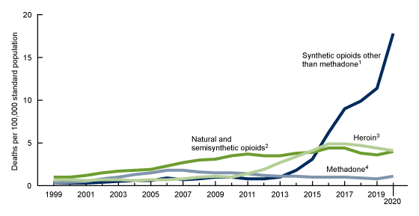
Fig. 9: Graph retrieved from “Age-adjusted rates of drug overdose deaths involving opioids, by type of opioid: United States, 1999–2020” Published in Data Briefs Number 428. December 2021 [10].

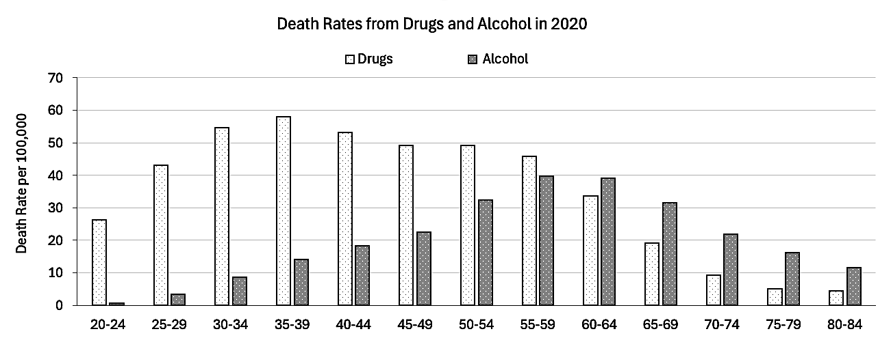
Fig. 10A: This graph was generated from data downloaded from CDC Wonder interactive website [12].

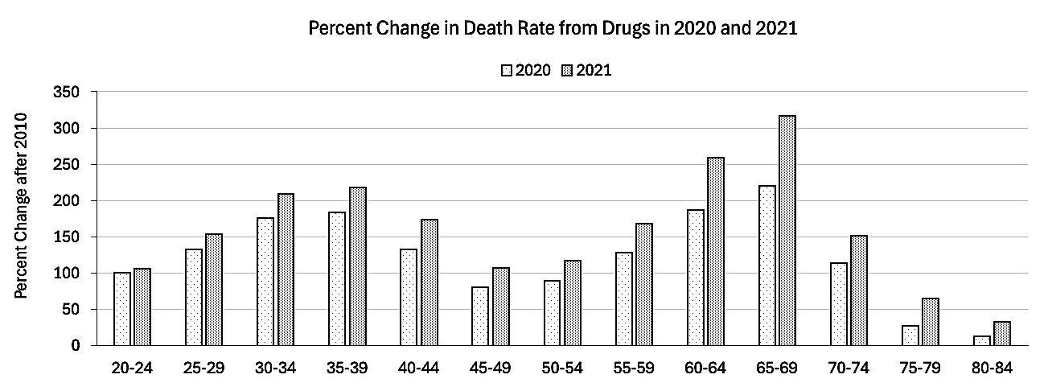
Fig. 10B: This graph was generated from data downloaded from CDC Wonder interactive website [12].

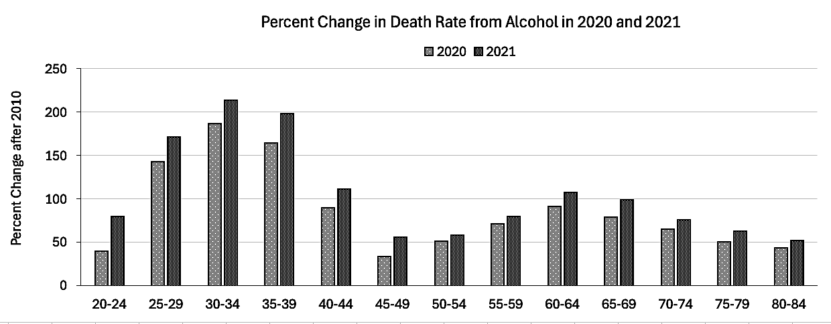
Fig. 10C: This graph was generated from data downloaded from CDC Wonder interactive website [12].

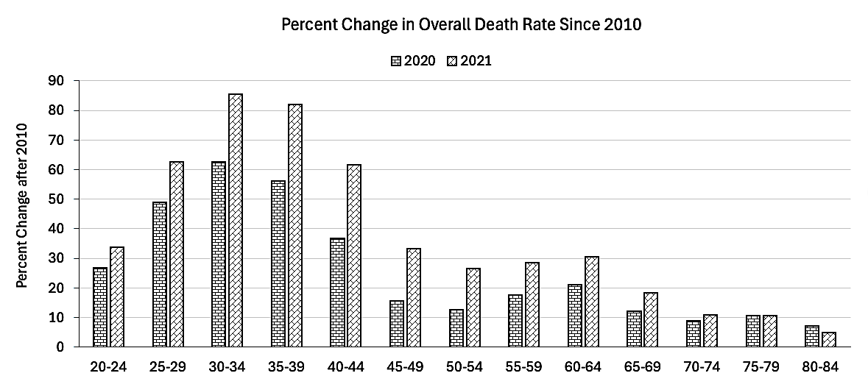
Fig. 10D: This graph was generated from data downloaded from “Annual Death Rates by Age Group” at OurWorldinData.org [4].

Drugs are not the only form of substance abuse that contributed to higher death rates. Alcohol-related deaths also surged following the pandemic, with most deaths from alcohol centering around ages 55-64 (Fig. 10A and Table 1). However, after 2015 overdose deaths in this age group started to surge to a point where they surpassed death from alcohol in 2021 (Fig. 11C).

Deaths from overdose and alcohol for ages 30-39 peaked at about 63.2 per 100,000 in 2021 (Fig. 11A), the same year that US life expectancy declined to its lowest point in over two decades. In 2021 substance abuse deaths exceeded a third of overall deaths for this age group (Fig. 11B). For ages 55-64 (the group most affected by alcohol) substance abuse death rates remained below 10 percent of overall death rates when the peaked in 2023 (Fig. 11D).

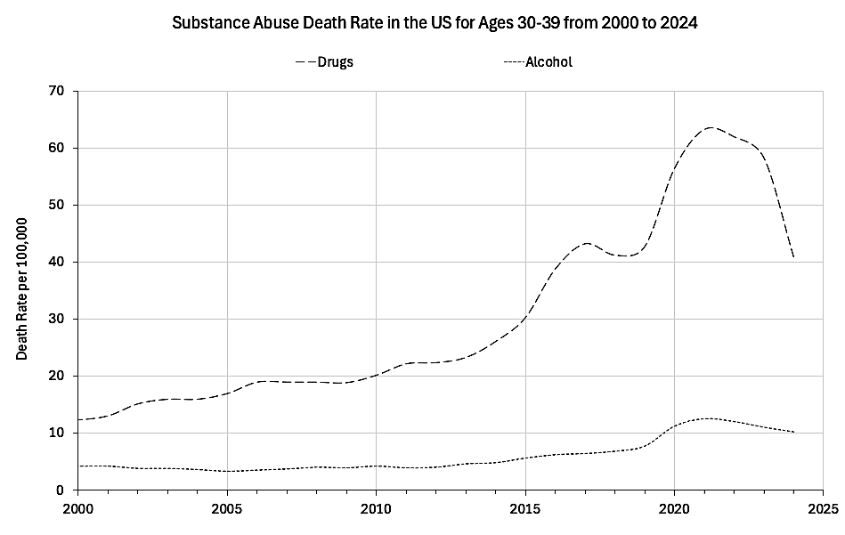
Fig. 11A: This graph was generated from data downloaded from CDC Wonder interactive website [12].

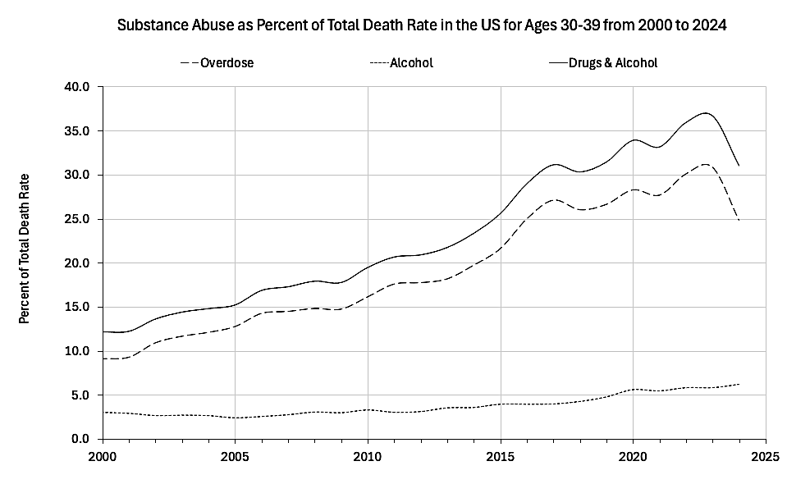
Fig. 11B: This graph was generated from data downloaded from CDC Wonder interactive website [12].

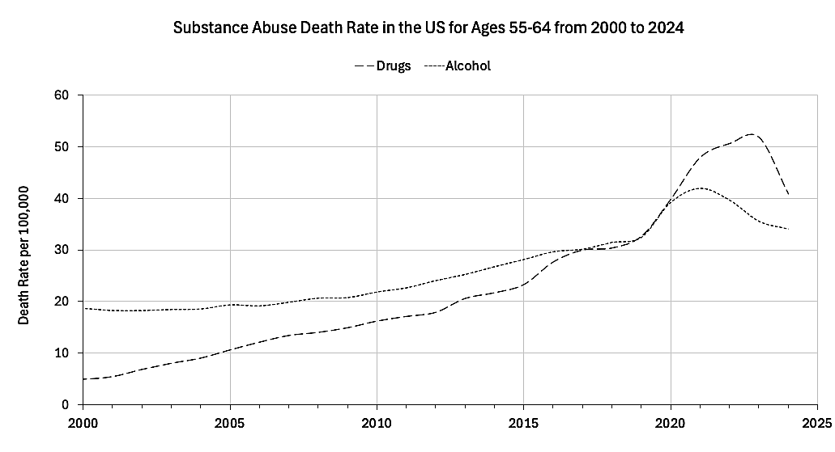
Fig. 11C: This graph was generated from data downloaded from CDC Wonder interactive website [12].

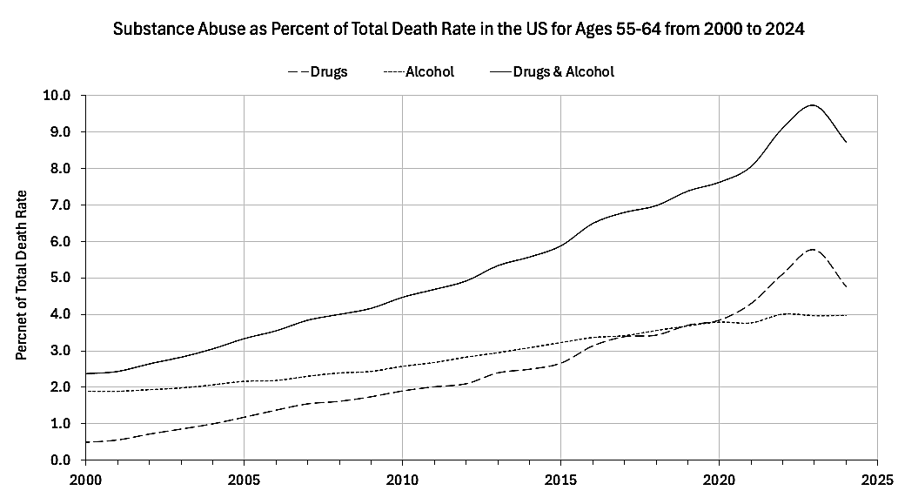
Fig. 11D: This graph was generated from data downloaded from CDC Wonder interactive website [12].

Age | Drug deaths  / 100K  in 2010 | Drug deaths  / 100K  in 2020 | Alcohol deaths  / 100K  in 2010 | Alcohol deaths  / 100K  in 2020 | Total deaths  / 100K  in 2010 | Total deaths  / 100K  in 2020 | Total COVID  deaths  in 2020 | Total COVID  deaths  in 2021
20-24 | 13.1 | 26.2 | 0.5 | 0.7 | 86 | 109 | 2,890* | 4,250*
25-29 | 18.5 | 43.1 | 1.4 | 3.4 | 96 | 143 | 2,890* | 4,250*
30-34 | 19.8 | 54.7 | 3 | 8.6 | 110 | 179 | 9,680 | 14,280
35-39 | 20.5 | 58.1 | 5.3 | 14.0 | 139 | 217 | 9,680 | 14,280
40-44 | 22.9 | 53.2 | 9.6 | 18.2 | 201 | 275 | 18,770 | 28,400
45-49 | 27.2 | 49.1 | 16.9 | 22.6 | 325 | 376 | 18,770 | 28,400
50-54 | 25.9 | 49.1 | 21.4 | 32.3 | 492 | 554 | 89,650 | 128,490
55-59 | 20.1 | 45.9 | 23.2 | 39.7 | 710 | 834 | 89,650 | 128,490
60-64 | 11.7 | 33.6 | 20.4 | 39.0 | 1015 | 1229 | 89,650 | 128,490
65-69 | 6 | 19.2 | 17.6 | 31.5 | 1528 | 1712 | 98,420 | 142,180
70-74 | 4.3 | 9.2 | 13.2 | 21.8 | 2335 | 2542 | 98,420 | 142,180
75-79 | 4 | 5.1 | 10.7 | 16.1 | 3728 | 4120 | 102,890 | 145,320
80-84 | 4 | 4.5 | 8.1 | 11.6 | 6379 | 6833 | 102,890 | 145,320
85+ | N/A | N/A | N/A | N/A | 795330 | 983900 | 88,450 | 128,680
Table 1: This table was made from data downloaded from CDC Wonder interactive website [12], “Annual Death Rates by Age Group” at OurWorldinData.org [4], and “COVID Deaths by Year | Statistics & Facts” at theglobalstatistics.com [9].

If we compare deaths from drug overdose to deaths from COVID-19 for Americans ages 18-74, we get 94,220 from COVID versus 219,410 from drugs in 2020, and then 109,035 versus 317,600 in 2021 [9,11]. Unsurprisingly, younger Americans were most affected by drugs, and for ages 30-39 deaths from drugs and alcohol combined exceeded deaths from COVID-19 by a factor of slightly more than 3:1 (Graph 12).

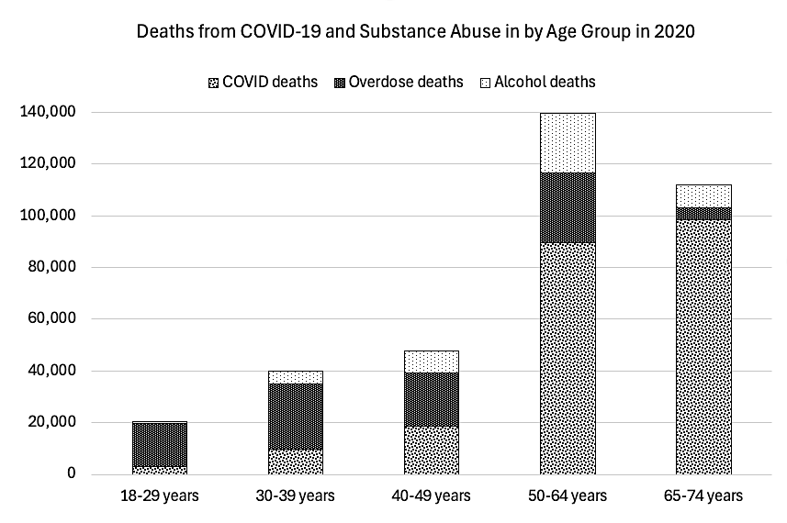
Fig. 12: This graph was generated from data downloaded from CDC Wonder interactive website [12], and “COVID Deaths by Year | Statistics & Facts” at theglobalstatistics.com [9].

Discussion:
Overdose deaths are the main driver of life expectancy decline in 2020-2021, but 2010 was chosen as the baseline for most of the charts because this is when overall death rates for ages 30-39 had reached their lowest point, despite overdose deaths having risen steadily since 2000 (Fig. 11A-11D). Overall deaths for ages 30-39 proceeded to rise only after overdose deaths overwhelmed confounding variables that (prior to 2010) had “absorbed” their effect on overall deaths. The baseline year for ages 65-74 in Fig. 7 is 2019 because elderly Americans were minimally affected by opioids prior to the pandemic.

Previous authors had singled out drug overdose as the leading cause of life expectancy decline, but these articles were written prior to the countermeasures that greatly worsened this epidemic in 2020 [13,14,15]. A handful of articles written after the start of the pandemic acknowledged the effect of overdose on life expectancy, but only with greater emphasis on deaths from the coronavirus even though three times more Americans aged 30-39 were dying from overdose (Fig. 12) and nearly half of the adult deaths attributed to COVID-19 occurred in people over the age of 74 (Table 1) [16,17,18].

Dr. Pierre Kory rose to national prominence in 2020 after testifying before congress on alternative treatments for COVID-19 [19]. and in 2023 Kory co-authored an article in USA Today on the “unknown phenomenon” of excess deaths for Americans aged 35-44 years old in 2021. Then later in an interview Kory blamed these deaths on vaccine injury, even though life expectancy had already risen dramatically before the vaccine was rolled out in 2021 (Fig. 3). More astonishingly, Kory then went on to downplay the significance of the opioids by arguing that fentanyl “had already been around ten years,” even though 2021 happened to be the worst year for opioid deaths [2,22]. Dr. Kory’s hypothesis is disputed, but in view of his stature in the alternative medicine community it merits a response: According to reports submitted to the CDC’s Vaccine Adverse Event Reporting System* annual deaths from vaccine injury rose from the single digits 2015-2019 to 220 in 2021 for Americans aged 30-39 [23]. This spike in deaths is deeply troubling and merits further investigation, but even if these vaccine-attributed deaths are underreported by a factor of ten they would still add up to less than 10% to the 28,695 deaths attributed to drugs during the same year for this age group [11]. In addition, 76% of adult deaths attributed to vaccination in 2021 occurred in Americans 65 and older (Table 2) and this age group was far less impacted by the 2021 surge in death rates (Fig. 3 and 4).

Age | Deaths attributed to vaccination in 2021*
18-29 | 134
30-39 | 220
40-49 | 363
50-59 | 779
60-64 | 755
65-79 | 3,546
80 + | 3,572

Table 2: This table was made from data downloaded from the CDC Wonder interactive website based on the Vaccine Adverse Event Reporting System²⁴.
*VAERS was organized solely for the purpose of detecting overall safety signals, but due to lack of routine verification there is no guarantee that each report is accurate or that the vaccine was necessarily the causative agent.

At any rate, from January of 2020 to December of 2024, 497,205 Americans died from drug overdose. If we add in the numbers from 5 years prior to the pandemic, the number surges to 823,445 over 10 years [24]. For perspective, 416,800 Americans were killed in action during their 3.7 years of participation in World War II [25].

In 2025 annual overdose deaths proceeded to decline from its maximum of 111,451 total deaths in 2023 to pre-pandemic levels of 68,372 per year, but sadly, this far exceeds the 17,415 deaths recorded in 2000; the year before US death rates from opioids started to surpass those of its OECD counterparts (Graph 8) [2,12,24]. For more perspective, 58,220 Americans were killed in action during the entire eight years the US fought in Vietnam [26].

These numbers are sobering, but what is even more astonishing is how an overdose epidemic that nearly doubled the death rate Americans in their prime working years was overshadowed by a pandemic that killed senior citizens at a rate comparable to that of a bad flu season. Strategies for scaling back the ongoing carnage are beyond the purview of this investigation, but for starters we need to alert conscientious policymakers who are up to the challenge of re-ordering the priorities of public health.

Acknowledgements: I would like to thank data analysts Mark Kulacz for sharing his insight on the opioid epidemic, neurobiologist and biology coach Jonathan Couey for explaining the role of demographics, and mathematics instructor Stephen Kcenich for directing me to the Social Security’s actuarial life table which I used to generate the graphs that formed the central basis of this investigation.

Literature Cited:
- Saloni Dattani, Lucas Rodés-Guirao, Hannah Ritchie, Esteban Ortiz-Ospina, and Max Roser (2023) - “Life Expectancy” Published online at OurWorldinData.org. Retrieved from: https://ourworldindata.org/life-expectancy [Online Resource]
- Max Roser (2020) - “Why is life expectancy in the US lower than in other rich countries?” Published online at OurWorldinData.org. Retrieved from: https://archive.ourworldindata.org/20260512-185716/us-life-expectancy-low.html [Online Resource] (archived on May 12, 2026).
- Social Security “Actuarial Life Table” Published online at ssa.gov. Retrieved from:
https://www.ssa.gov/oact/STATS/table4c6.html [Online Resource]
- Human Mortality Database (2025) – with minor processing by Our World in Data. “Central death rate at birth – HMD – period tables” [dataset]. Human Mortality Database, “Human Mortality Database” [original data]. Retrieved from:
https://ourworldindata.org/grapher/annual-death-rate-by-age-group?time=2006
[Online Resource]
- Jason Devine (2017) “Two States, A Third of Counties Have More Deaths Than Births” Published online at census.gov. October 24, 2017. Retrieved from:
https://www.census.gov/library/stories/2017/10/aging-boomers-deaths.html
[Online Resource]
- CDC (2026) “About Estimated Flu Burden” Published online at cdc.gov. Retrieved from:
https://www.cdc.gov/flu-burden/php/about/index.html [Online Resource]
- USA Facts “How many people live in the US” Published online at usafacts.org. Retrieved from: https://usafacts.org/answers/how-many-people-live-in-the-us/country/united-states/?endDate=2021-01-01&startDate=2010-01-01 [Online Resource]
- UN, World Population Prospects (2024) – processed by Our World in Data. “Number of children who die before age 5 – UN WPP” [dataset]. United Nations, “World Population Prospects”; United Nations, “World Population Prospects - Interim Update”
[original data]. Retrieved from:
https://ourworldindata.org/grapher/annual-deaths-by-age?time=2010&country=~USA [Online Resource]
- The Global Statistics “COVID Deaths by Year | Statistics & Facts” Published online at theglobalstatistics.com. Retrieved from: https://www.theglobalstatistics.com/covid-deaths-by-year/ [Online Resource]
- Holly Hedegaard, Arialdi Miniño, Merianne Rose Spencer, and Margaret Warner (2021) “Drug Overdose Deaths in the United States, 1999–2020” NCHS Data Brief No. 428, December 2021. Published online at cdc.gov. Retrieved from: https://www.cdc.gov/nchs/products/databriefs/db428.htm
[Online Resource]
- CDC (2021) “Data table for Figure 4. Age-adjusted rates of drug overdose deaths involving opioids, by type of opioid: United States, 1999–2020” CHS Data Brief, Number 428, December 2021. Published online at cdc.gov. Retrieved from:
https://www.cdc.gov/nchs/data/databriefs/db428-tables.pdf#4 [Online Resource]
- CDC (2026) “National Center for Health Statistics
Mortality Data on CDC WONDER” (Reviewed May 12, 2026) Published online at wonder.cdc.gov. Retrieved from: https://wonder.cdc.gov/deaths-by-underlying-cause.html [Online Resource]
- Sabrina Tavernise (2016) “Life Expectancy for White Americans Drops Slightly; Analysts
Cite Drug Overdoses” April 20, 2016. The New York Times.
- Sabrina Tavernise and Abby Goodnough (2020) “Life Expectancy of Americans Rises for First Time in Four Years.” January 30, 2020 The New York Times
- https://link.springer.com/article/10.1007/s11524-022-00610-0
- https://www.health.harvard.edu/blog/why-life-expectancy-in-the-us-is-falling-202210202835
- https://www.politico.com/news/2022/12/22/covid-19-and-overdose-deaths-drive-u-s-life-expectancy-to-a-25-year-low-00075081
- https://www.cpr.org/2022/06/25/colorado-life-expectancy-falls-covid-overdose-deaths/
- https://www.hsgac.senate.gov/wp-content/uploads/imo/media/doc/Testimony-Kory-2020-12-08.pdf
- https://www.usatoday.com/story/opinion/2023/08/11/more-americans-dying-than-before-pandemic-covid-deaths/70542423007/
- https://childrenshealthdefense.org/defender/washington-post-life-expectancy-covid-vaccines/
- https://rumble.com/v48tlk6-young-people-are-dying-at-staggering-rates-w-dr.-pierre-kory.html
- https://wonder.cdc.gov/vaers.html
- https://www.cdc.gov/nchs/nvss/vsrr/drug-overdose-data.htm
- https://www.nationalww2museum.org/students-teachers/student-resources/research-starters/research-starters-worldwide-deaths-world-war
- https://www.archives.gov/research/military/vietnam-war/casualty-statistics

