Review the items on federal land and post twice. For your first post, answer two of the three questions below (6 points):
- Describe an item that surprised, interested, pleased and/or made you upset and explain why this item made you feel this way.
- The Utah legislature characterized Barrack Obama’s designation of Bear’s Ears as a “land grab.” The Sierra Club characterized Donald Trump’s reversal of this designation as a “land grab.” Do either or both sides have a legitimate complaint?
- Federal land ownership in Western states ranges from 30% in Oregon to 85% in Nevada. In sharp contrast, federal land ownership in Eastern states ranges from 1% in New York to 13% in New Hampshire. Do you think this is fair to residents in Western states? Explain your reasoning.
- Do you think park rangers were heavy-handed in their treatment of tourists visiting national parks during the government shutdown? Why do you think they acted this way?
- Some have proposed converting national parks into state parks because state governments are more accountable to their constituents and state parks are less likely to be affected by federal government shutdowns. Do you think state governments can preserve these lands as effectively as the federal government? Explain your reasoning.

For the second posting you need to respond to one post by another fellow student. The second posting is worth 3 points. For the second posting I recommend the following format:
1) I like how ….. because…..
or
2) I agree/disagree with…..because….
or
3) This relates to…..because…..
Here are items you need to review:
This map illustrates the percentage of federal land per state:
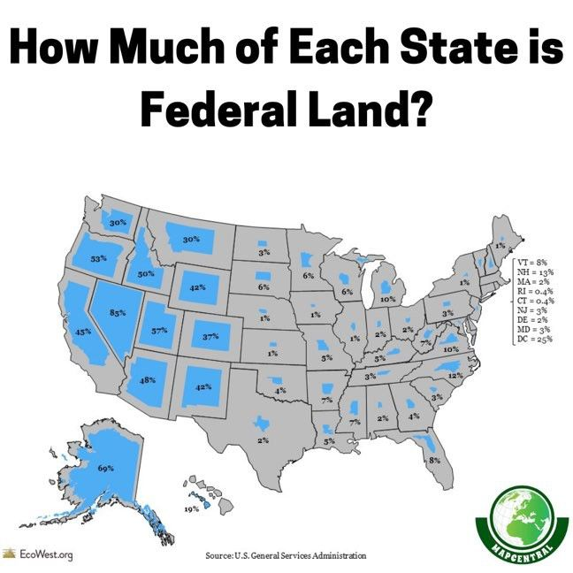

This video presents a short history of federal land ownership:
https://www.scrippsnews.com/us-news/this-land-is-whose-land-a-history-of-federal-land-ownership
This chart from Business Insider ranks presidents in terms of how they designated national monuments:
https://www.businessinsider.com/us-presidents-who-preserved-most-public-lands-antiquities-act-2017-10

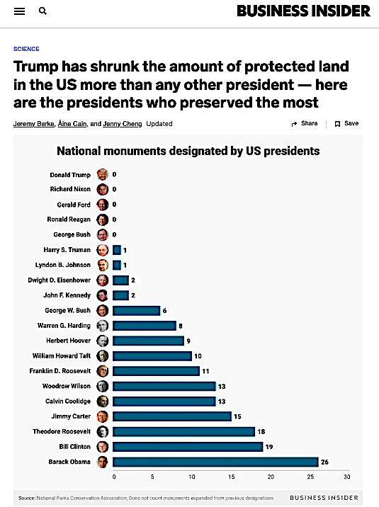

This article critiques Trump’s reversal of “Bear’s Ears” status as a national monument:
https://www.sierraclub.org/sierra/feature/land-grab-trumps-campaign-against-bears-ears-national-monument
This article discusses the Utah legislature’s objection to the Bear’s Ear’s designation:
https://www.deseret.com/2017/2/3/20605415/utah-legislature-votes-to-shed-bears-ears-monument-designation/
This article proposes reforming the way national monuments are designated:
https://www.daines.senate.gov/2017/01/06/daines-introduces-bill-to-reform-monument-designation-process/
This article criticizes how government officials handled the 2013 government shutdown in national parks:
https://dailycaller.com/2013/10/08/gestapo-tactics-yellowstone-park-rangers-held-tour-group-captive/

