Review the items on the allergies and post twice. For your first post, answer two of the five questions below (8 points). To facilitate grading, please separate the two items you are addressing:

- Do you believe the “hygiene hypothesis” is supported? Explain your answer.*
- Peanut allergies were extremely rare prior to the 1990’s and the chart from the CDC shows how life-threatening food allergy events in children increased dramatically from 1998-2006. Can you think of any changes in hygiene during the last 30-40 years that could have played a role in the rising trend of childhood allergies?
- Do you believe the “injected vaccine hypothesis” is supported? Explain your answer.*
- Peanut allergies were extremely rare prior to the 1990’s and the chart from the CDC shows how life-threatening food allergy events in children increased dramatically from 1998-2006. Can you think of any changes in the childhood vaccine schedule during the last 30-40 years that could have played a role in the rising trend of childhood allergies?
- Do you think that special interests are disproportionately influencing research on the rising trend of childhood allergies? Explain.

* It is acceptable to fully or partially support both the hygiene and injected vaccine hypothesis. It is also acceptable to reject both of them.

For your second post you need to respond to a classmate (2 points). Below is a suggested format for responding:

- I like how ….. because…..
or
- I agree/disagree with…..because….
or
- This relates to…..because…..

Here are the items:

This chart from the CDC indicates a rising trend in life-threatening food allergy events in children:

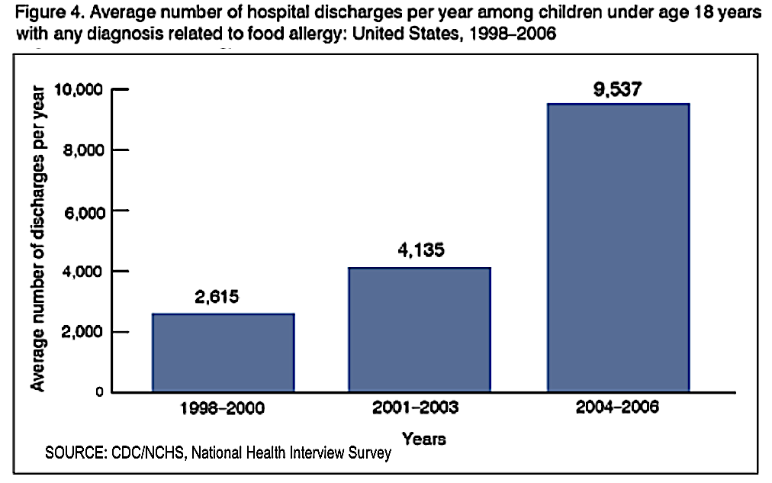

According to the “hygiene hypothesis,” babies raised in “clean” households are more inclined to have allergies due to lack of exposure to certain strains of bacteria. The article below summarizes a study that shows a correlation between hygiene and the likelihood of having allergies:
https://hub.jhu.edu/2014/06/09/newborns-allergy-asthma-risk/

This chart from the cited study shows significantly lower asthma rates in 3-year olds exposed to allergens in their first year of life: https://www.jacionline.org/article/S0091-6749(14)00593-4/fulltext

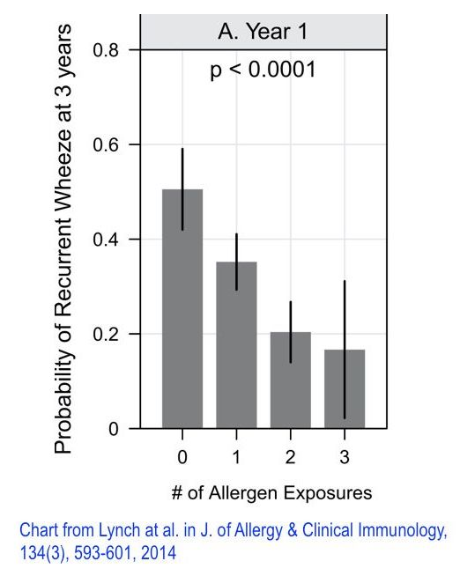

This passage from "The Peanut Allergy Epidemic" by Heather Fraser presents the "vaccine hypothesis," whereby the increasing number of vaccines on the US childhood schedule is playing a role in the growing number of childhood allergies. I highlighted key portions of the passage in blue (See attached pdf):
https://www.utne.com/food/peanut-allergy-epidemic-ze0z1606zcbru/

Here is a table from the Japanese study cited by Fraser. Note how nearly half the children who received the gelatin-containing DTAP had allergic reactions to gelatin (54 out of 126). This allergic response was undetected in the control group (0 out of 29):
https://www.jstage.jst.go.jp/article/yoken/53/5/53_JJID.2000.189/_pdf/-char/en

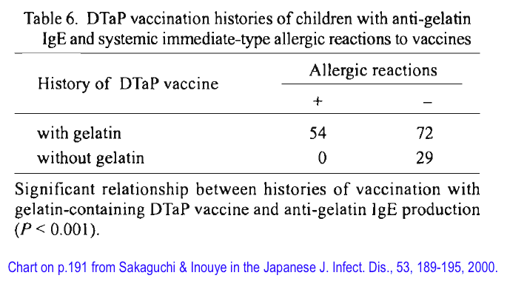

The top chart indicates how the US childhood vaccine schedule expanded after passage of a 1986 law that provided liability protection to manufacturers of childhood vaccines that were FDA approved. The bottom chart compares current US recommendations with sample recommendations from the EU:

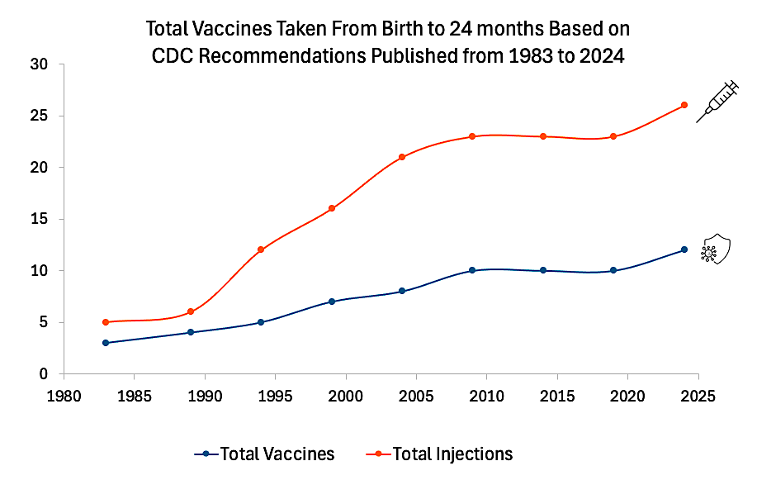

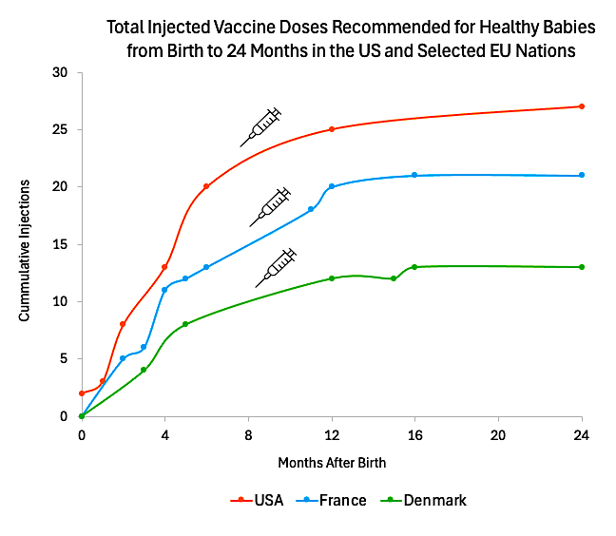

Chart data was obtained from these two sources:
https://www.cdc.gov/vaccines/hcp/imz-schedules/resources.html?CDC_AAref_Val=https://www.cdc.gov/vaccines/schedules/hcp/schedule-related-resources.htmeneral

https://vaccine-schedule.ecdc.europa.eu/

