Review the items on the allergies and post twice. For your first post, answer two of the five questions below (6 points):

- Do you believe the “hygiene hypothesis” is supported? Explain your answer.*
- Peanut allergies were extremely rare prior to the 1990’s and the chart from the CDC shows how life-threatening food allergy events in children increased dramatically from 1998-2006. Can you think of any changes in hygiene during the last 30-40 years that could have played a role in the rising trend of childhood allergies?
- Do you believe the “injected vaccine hypothesis” is supported? Explain your answer.*
- Peanut allergies were extremely rare prior to the 1990’s and the chart from the CDC shows how life-threatening food allergy events in children increased dramatically from 1998-2006. Can you think of any changes in the childhood vaccine schedule during the last 30-40 years that could have played a role in the rising trend of childhood allergies?
- Do you think that special interests are disproportionately influencing research on the rising trend of childhood allergies? Explain.

* It is acceptable to fully or partially support both the hygiene and injected vaccine hypothesis. It is also acceptable to reject both hypothesis.

For your second post you need to respond to a classmate (3 points). Below is a suggested format for responding:

- I like how ….. because…..
or
- I agree/disagree with…..because….
or
- This relates to…..because…..

Here are the items:

This chart from the CDC indicates a rising trend in life-threatening food allergy events in children:

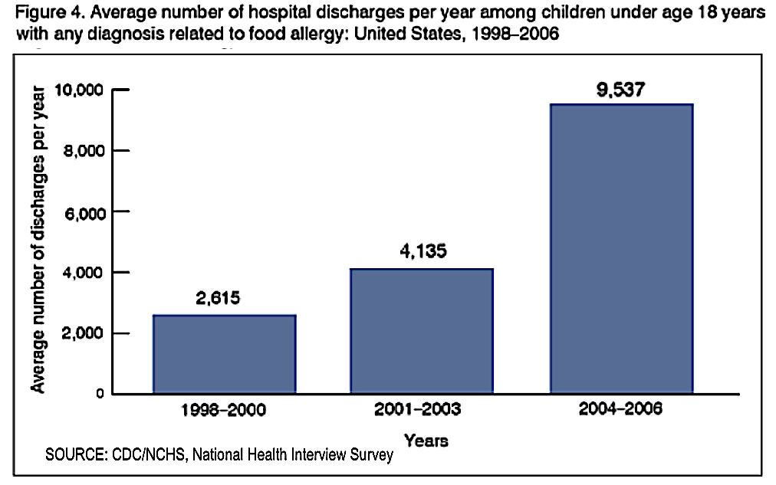

According to the “hygiene hypothesis,” babies raised in “clean” households are more inclined to have allergies due to lack of exposure to certain strains of bacteria. The article below summarizes a study that shows a correlation between hygiene and the likelihood of having allergies:
https://hub.jhu.edu/2014/06/09/newborns-allergy-asthma-risk/

This chart from the cited study shows significantly lower asthma rates in 3-year olds exposed to allergens in their first year of life: https://www.jacionline.org/article/S0091-6749(14)00593-4/fulltext

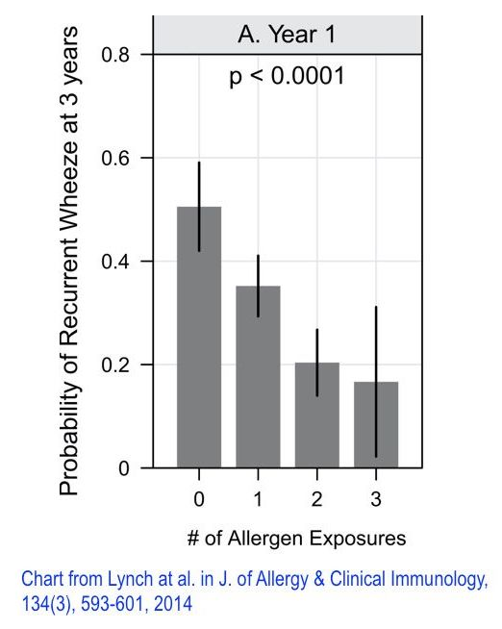

This passage from "The Peanut Allergy Epidemic" by Heather Fraser presents the "vaccine hypothesis," whereby the increasing number of vaccines on the US childhood schedule is playing a role in the growing number of childhood allergies. I highlighted key portions of the passage in blue (See attached pdf):
https://www.utne.com/food/peanut-allergy-epidemic-ze0z1606zcbru/

Here is a table from the Japanese study cited by Fraser. Note how nearly half the children who received the gelatin-containing DTAP had allergic reactions to gelatin (54 out of 126). This allergic response was undetected in the control group (0 out of 29): https://www.niid.go.jp/niid/images/JJID/R-9.pdf

