Did CARES Act Funding Influence the Reporting of Deaths from COVID-19?

Antonio R. Chaves
Adjunct instructor of biology at Montgomery College in Takoma Park, MD

Correspondence to: Antonio.Chaves@montgomerycollege.edu

Abstract:
Background: The first round of CARES Act payments were distributed in April of 2020 in order to offset economic and medical costs incurred by the pandemic. Payments per state varied widely, with rural states often receiving 10-20 times more funding per case than their more urbanized counterparts. After the funds were made available some doctors claimed that they were being pressured to inflate their COVID cases.
Methods: All data used in the charts was retrieved from internet-accessible databases of governmental and non-governmental sources.
Results: Regression analysis indicates a significant correlation between funding per case and increase in reported COVID deaths per state from 2020 to 2021 (p < 0.01, n = 50). Nearly all deaths attributed to COVID-19 were pneumonia-related, and regression analysis of the states also indicates a robust correlation between pneumonia deaths in 2021 and pre-existing health indicators from 2018 (r = -0.77). This correlation becomes much weaker when the same health indicators are compared with (pre-CARES Act) pneumonia deaths in 2019 (r = -0.37). The stronger correlation of 2021 implies that CARES payments encouraged hospitals to attribute more deaths from pre-existing conditions to COVID-related pneumonia. If we compare weekly pneumonia deaths in 2021-2022 against (pre-COVID) pneumonia deaths reported in 2019, we get five peaks of excess pneumonia deaths between the spring of 2020 and the winter of 2021-2022. The two off-season peaks that occur after CARES payments were made available involve a disproportionate number of deaths under the age of 65. These peaks also coincide with surges in overdose death, and the aforementioned correlation between CARES payments and COVID deaths is significantly higher for 5-year age cohorts for ages 20-44 (n = 5, mean r value = 0.49± 0.032) versus ages 45-84 (n = 8, mean r value = 0.36± 0.015) (p <0.001). Pulmonary complications are a common cause of death in opioid overdose victims and the plausibility that some instances of overdose-driven pneumonia being misattributed to COVID-19 is laid out in the discussion.
Conclusions: Regression analysis indicates that nearly all deaths attributed to COVID-19 are pneumonia related and CARES payments are likely to have encouraged hospitals to inflate the number of deaths attributed to COVID-driven pneumonia from 2021-2022. It is also plausible that a significant portion of the COVID- pneumonia deaths reported in Americans under the age of 65 were in reality, the result of pulmonary complications from drug overdose.

Introduction: The CARES Act (Coronavirus Aid Relief and Economic Security) was passed in order to mitigate the economic and medical costs of the pandemic. After the $2 trillion program was signed into law in March 2020, 100 billion of the CARES budget was allocated to hospitals and other health care providers to cover the costs of testing, diagnosis, and treatment of COVID-19. Funding per state was reportedly based on broad estimates of Medicare revenue, but resulted in massive disparities whereby a many rural states like Nebraska and West Virginia received about 20 times more funding per case than states harder hit by the pandemic like New Jersey and New York [1, 2, 3]. In the months that followed, some doctors claimed they were pressured to list COVID-19 on the death certificate so hospitals and families could “cash in” on the 20% add on to Medicare costs and the $10,000 to families for funeral expenses [4, 5]. With US deaths certificates allowing coroners to list as many as four events resulting in death (with an additional section for “other significant conditions leading to death”), associating COVID-19 with other pulmonary complications seemed like less of a stretch to stakeholders seeking to benefit from these payments [6].
We may never get a precise estimate on the number of Americans who died of COVID-19, but statistical analysis of the data can shed light on patterns or discrepancies that indicate whether or there is any merit to allegations that government incentives adversely affected the accuracy of patient records attributed to COVID-19.

Methods: All data used in the charts was retrieved from the websites of governmental and non-governmental sources. These include the Centers for Disease Control and Prevention (death rates from influenza, pneumonia, and COVID-19), Becker’s Hospital Review (CARES payments per state), United Health Foundation (health scores per state), and the US Social Security Administration (annual risk of dying by age group).

Results: When comparing states, there is a statistically significant correlation between amount of payments per case and percent change in COVID deaths (r = 0.37, p < 0.01) (Fig.1). This relationship becomes more robust when the sample is narrowed down to ages 35-44 (r = 0.52, p < 0.001) (Fig.2).

Fig.1: Histogram generated from data published on Becker’s Hospital Review and the CDC Wonder website under the database category “Underlying Cause of Death” followed by subcategory “COVID-19” organized by “State” [1, 7].
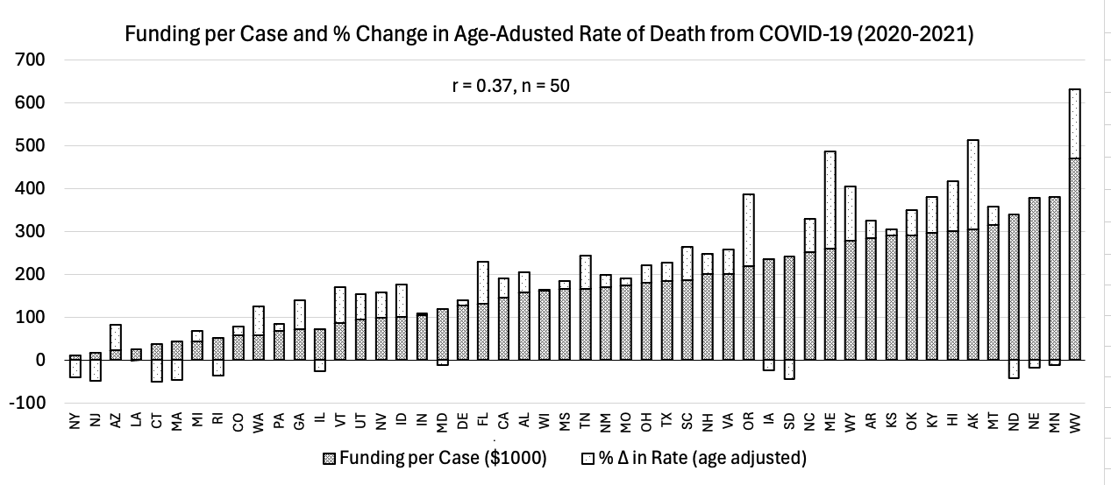

Fig.2: Histogram generated from data published on Becker’s Hospital Review and the CDC Wonder website under the database category “Underlying Cause of Death” followed by subcategory “COVID-19” organized by “Ten-Year Age Groups” and “State” [1, 7].
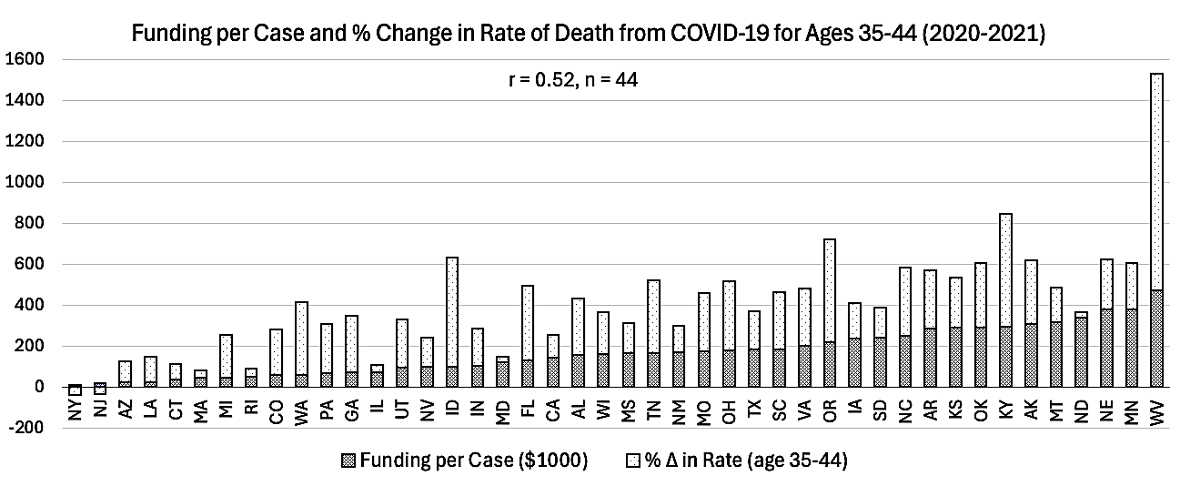

If this relationship is causal how might health institutions have inflated their COVID deaths without raising red flags? Reports of road fatalities being used to pad the numbers of COVID deaths (true or not) are not credible enough to have padded the numbers in a significant way [8]. The most effective way to embellish these reports “under the radar” is to conflate all ailments with flu-like symptoms with COVID-19.
Pneumonia is the 6th leading cause of death in the US and usually about 80% of pneumonia deaths occur in Americans 65 and older. This condition is generated by a wide range of pathogens and often develops as the result of a secondary infection in patients with influenza (Fig. 3). Even though pneumonia mortality exceeds influenza by a 3-10 ratio during flu season, these deaths are strongly correlated (Fig. 4).
Fig.3: Line graph generated from data published on the CDC Flu View Interactive website by downloading deaths from pneumonia and influenza during the (pre-COVID) years of 2017-2019 [9].
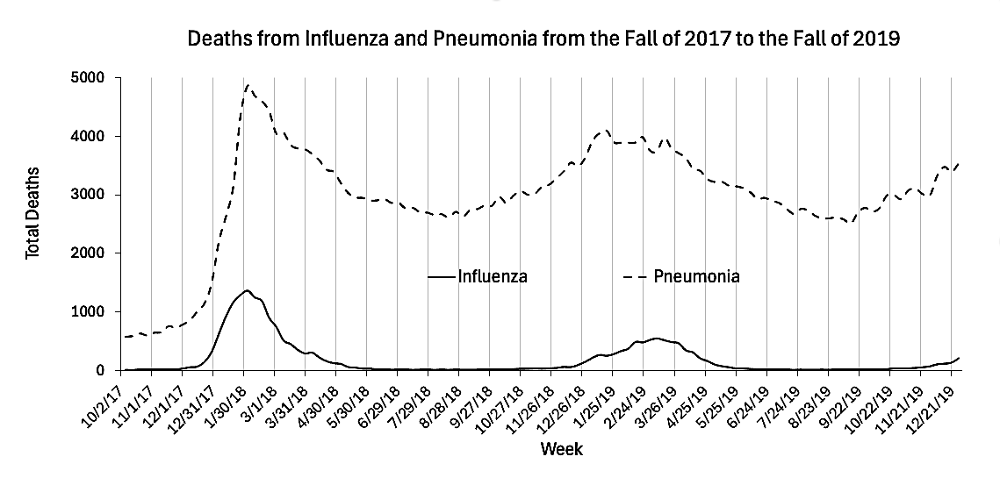

Fig.4: Scatter plot generated from data published on the CDC Flu View Interactive website by downloading deaths from pneumonia and influenza during the (pre-COVID) years of 2017-2019 [9].
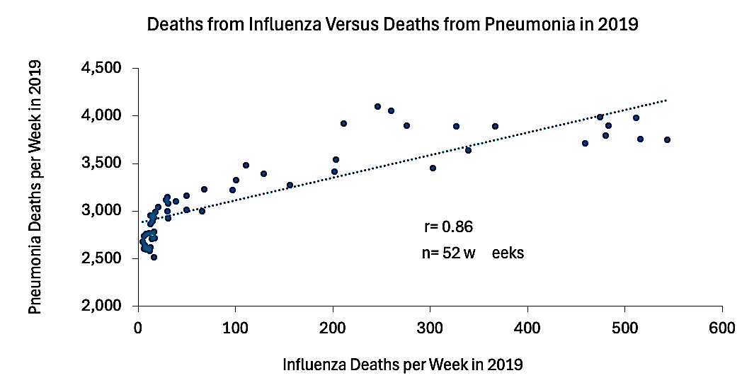

Annual deaths from influenza in the US declined 8,934 in 2020 to 1,107 in 2021 after it was allegedly “displaced” by COVID-19 [9, 10]. Unsurprisingly a large portion COVID patients succumbed to secondary pneumonia, but whereas pneumonia deaths always far exceed deaths from influenza, deaths from COVID-19 matched and frequently exceeded deaths from pneumonia (Fig. 5) and the correlation between COVID and pneumonia is nearly perfect (Fig. 6). This relationship implies that pneumonia played a role in most (if not all) deaths attributed to COVID-19.

Fig.5: Line graph generated from data published on the CDC Flu View Interactive website by downloading deaths from pneumonia and COVID-19 during the years of 2020-2022 [9].
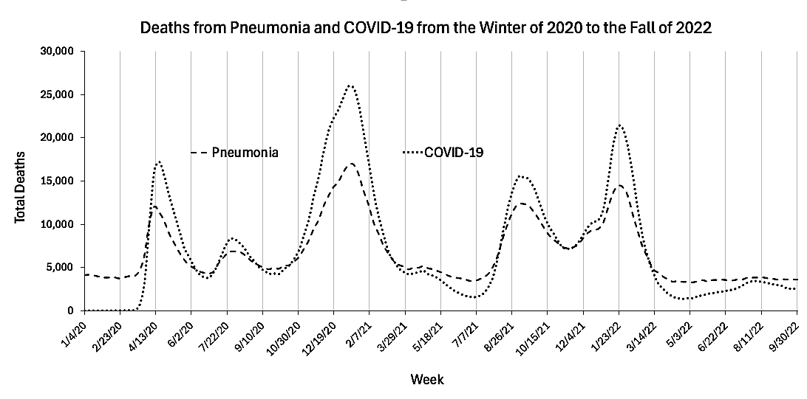

Fig.6: Scatter plot generated from data published on the CDC Flu View Interactive website by downloading deaths from pneumonia and COVID-19 during the years of 2020-2022 [9].
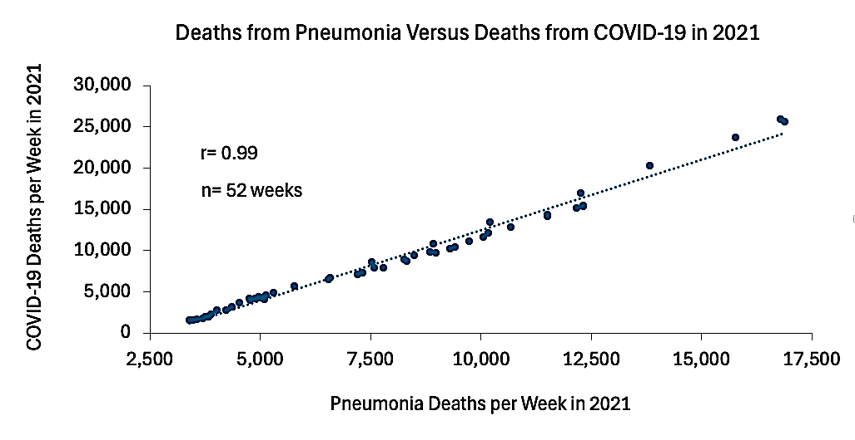

Regarding all deaths from COVID-19 as pneumonia-driven provides a useful perspective for assessing the virulence of this novel virus, and if we compare pneumonia deaths from 2020 to 2022 against the pre-COVID baseline of 2019, we get five distinct peaks of excess pneumonia deaths (Fig. 7). Peaks 1, 2, and 4 are notable in that they all occur outside flu season and Peaks 2 and 4 are even more unusual in that they affected significantly more Americans under the age of 65 (Fig. 8). Health parameters compiled in 2018 are also strongly correlated with pneumonia death rates per state in 2021. What are the implications?

First, the off-season peaks that occur after CARES Act funds had been distributed in April of 2020 (Peaks 2 and 4) support allegations that CARES payments incentivized hospitals to inflate their COVID cases [1, 2, 3].

Second, prior to the CARES Act, pneumonia deaths for under age 65 remained consistently near the 20% baseline regardless of season, but pneumonia and COVID deaths under age 65 significantly exceeded the baseline of 20% during Peaks 2 and 4 (Fig. 8) [9]. Both of these peaks occur after CARES payments were distributed.

Third, deaths from pneumonia under age 65 returned to the baseline low of 20 percent shortly after the start of 2022, and then by the end of April 2022 COVID-19 started to play a lesser role in deaths from pneumonia (Fig. 8). This timing also supports the aforementioned allegations because CARES payments expired on March 27, 2022 [11].

Fourth, there is a robust correlation between 2021 death rates from pneumonia and pre-existing health conditions reported in 2018 (Fig. 9). Since the weak and immunocompromised are most likely to die from pneumonia this relationship on its own is not surprising, but when the same pre-existing conditions are compared to (pre-COVID) pneumonia death rates in 2019 the correlation coefficient drops to -0.37 (graph not shown). This timing also concurs with the aforementioned allegations because (unless COVID-19 is simply more “efficient” at culling the weak) CARES payments could have incentivized hospitals to attribute a wider range of pre-existing conditions to COVID-19. It is also notable that the correlation coefficient increases to -0.84 when 2021 death rates from COVID-19 are compared with the same pre-existing conditions (graph not shown).

Fig.7: Line graph generated from data published on the CDC Flu View Interactive website [9].
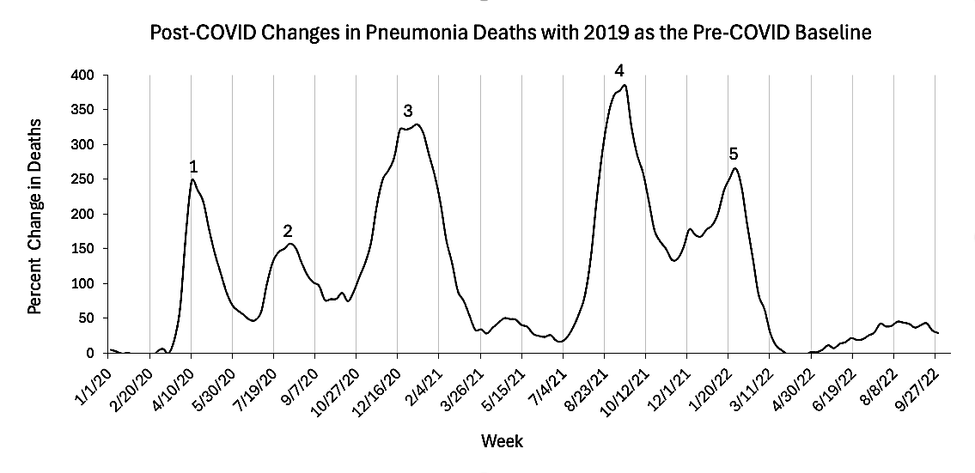

Fig.8: Line graph generated from data published on the CDC Flu View Interactive website based on pneumonia deaths under the age of 65 from the years 2019-2022 [9].
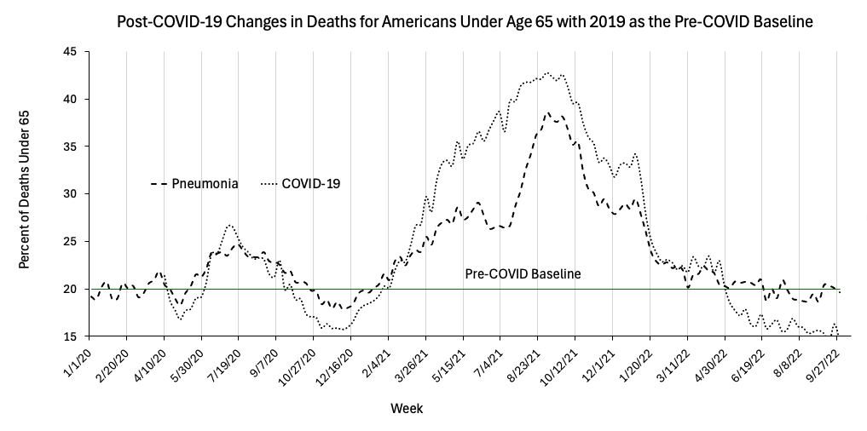

Fig.9: Scatter plot generated from data published by the United Health Foundation and the CDC Flu View Interactive website organized by state [9, 12].
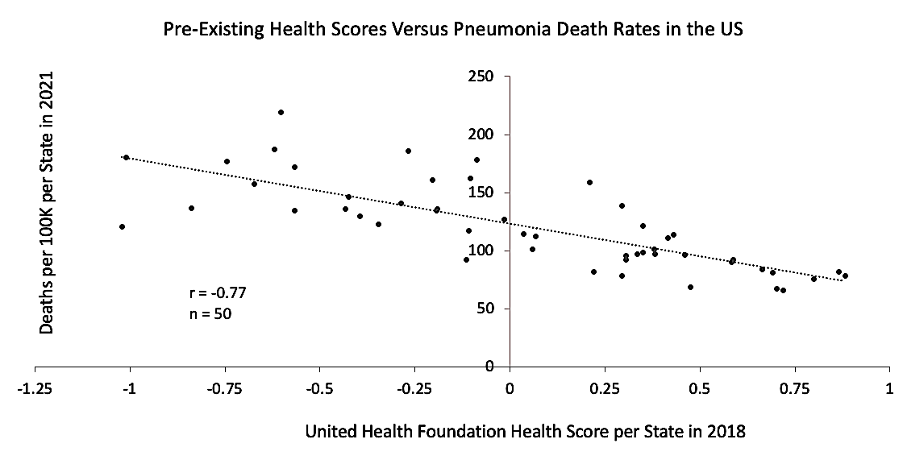

After CARES payments were distributed in 2020, health care officials in some states most affected during April-May of 2020 complained that Health and Human Services had allocated “a chunk of money without particular regard for who has been hardest hit”. The robust inverse correlation between CARES payments and April-May of 2020 supports these allegations (Fig. 10).

Fig.10: Histogram generated from data published on Becker’s Hospital Review and the CDC Flu View Interactive website under the database category “Underlying Cause of Death” followed by subcategory “pneumonia” organized by “State” [1, 9].
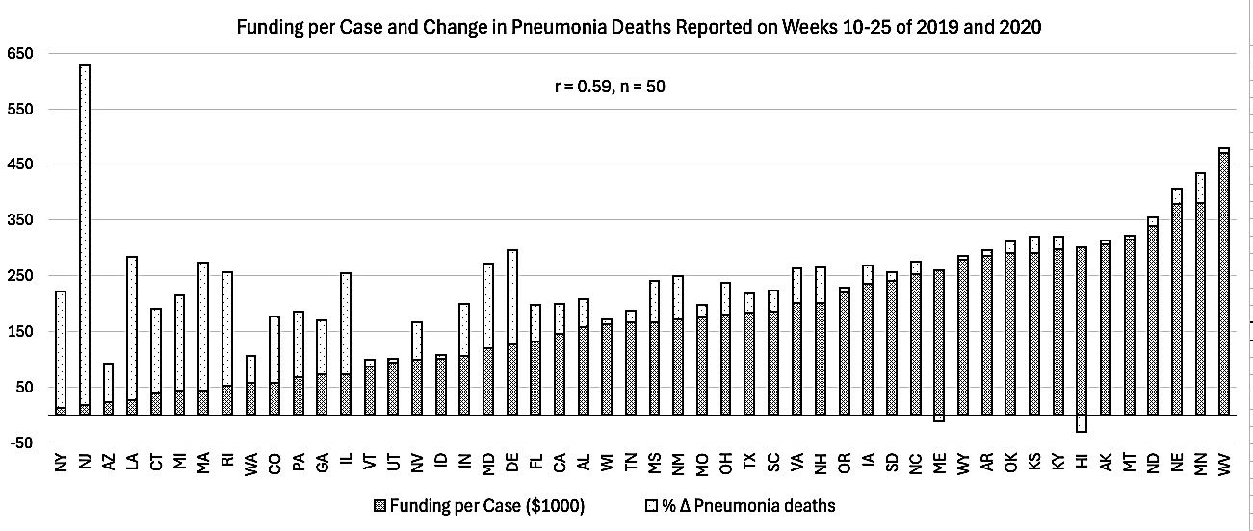

The virulence of SARS-Cov-2 is still being debated, but beyond dispute are surges in all-cause mortality following the harsh countermeasures that started in 2020 (Fig. 11A and 11B), and data from 2019-2022 on risk of dying organized by age group indicates that younger Americans were far more impacted than senior citizens. Even more surprisingly, the death rate for ages 75 and higher peaked in 2020, and then declined during what turned out to be deadliest year for ages 25-55. What was killing this disproportionate number of these young Americans in 2020-2021?

Data from the CDC indicates that the 2020-2021 surge death rates in the younger group was driven largely by drugs (mostly opioids) because overdose deaths in these age groups surged after pandemic-related countermeasures were enforced during the spring of 2020 (Fig. 12) [13].

Could overdose deaths have also played a credible role in padding the numbers of young people dying of COVID-pneumonia during the off-season pneumonia peaks that occurred after April of 2020 (Fig. 7 and 8)? Is this also why 5-year cohorts from ages 20-44 are more strongly correlated to CARES payments than 5-year cohorts from ages 45-84 (Table 1)? The plausibility of this scenario is laid out in the discussion.

Fig.11A and 11B: Line graphs generated from data published on the US Social Security Administration website [14].
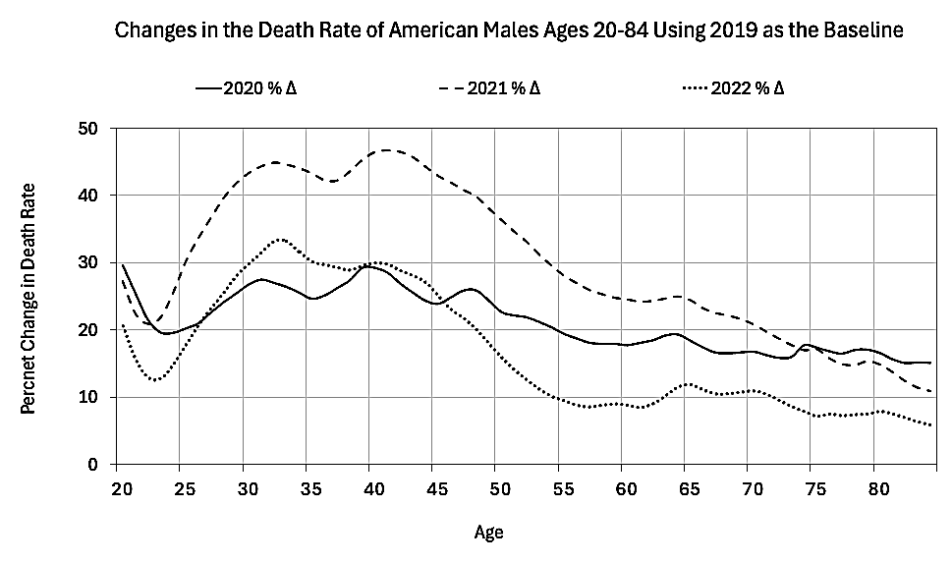
A
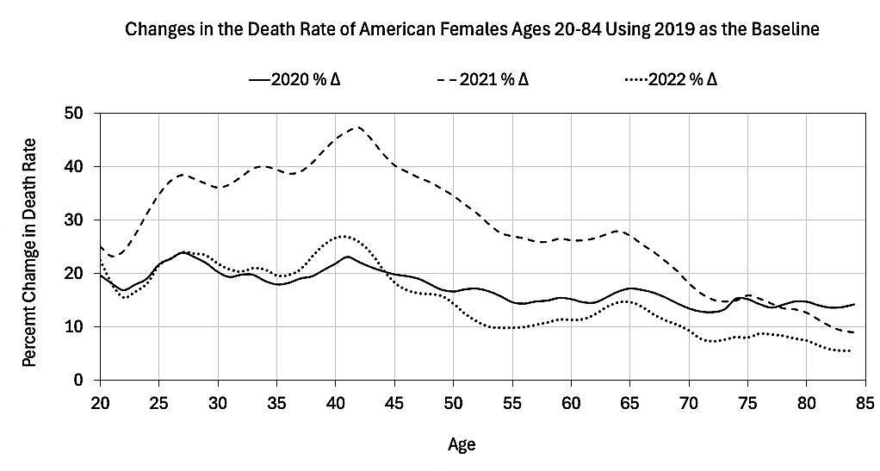
B

Fig.12: Graph generated from data published on the CDC Wonder website under the database category “Underlying Cause of Death” followed by subcategory “Drug/Alcohol Induced” [7].
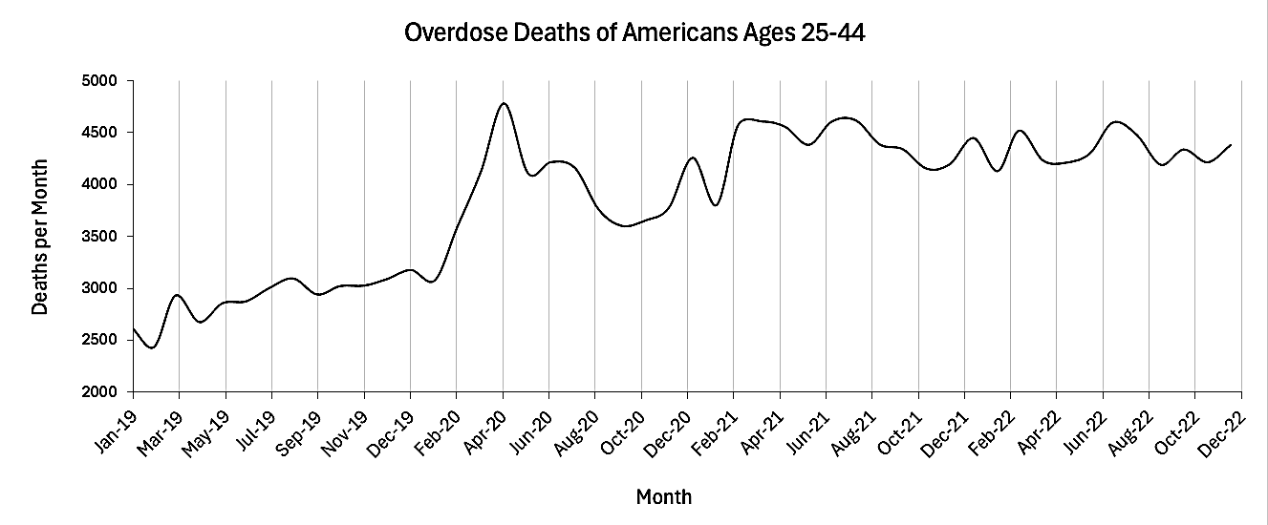

Table 1: Table generated from data published on Becker’s Hospital Review and the CDC Wonder website under the database category “Underlying Cause of Death” followed by subcategory “COVID-19” organized by “Five-Year Age Groups” [1, 7].
Ages | Correlation between CARES payments and % ∆ in COVID deaths 2020-2021 | Number of states in sample | Mean and standard error for ages 20-44 and 45-84  (T-test p < 0.001)
20-24 | r = 0.45 | n = 10* | 0.49 ± 0.032  n = 5
25-29 | r = 0.56 | n = 22* | 0.49 ± 0.032  n = 5
30-34 | r = 0.49 | n = 29* | 0.49 ± 0.032  n = 5
35-39 | r = 0.40 | n = 35* | 0.49 ± 0.032  n = 5
40-44 | r = 0.57 | n = 36* | 0.49 ± 0.032  n = 5
45-49 | r = 0.36 | n = 44* | 0.36 ± 0.015  n = 8
50-54 | r = 0.33 | n = 45* | 0.36 ± 0.015  n = 8
55-59 | r = 0.42 | n = 47* | 0.36 ± 0.015  n = 8
60-64 | r = 0.37 | n = 49* | 0.36 ± 0.015  n = 8
65-69 | r = 0.40 | n = 49* | 0.36 ± 0.015  n = 8
70-74 | r = 0.39 | n = 50 | 0.36 ± 0.015  n = 8
75-79 | r = 0.36 | n = 50 | 0.36 ± 0.015  n = 8
80-84 | r = 0.29 | n = 50 | 0.36 ± 0.015  n = 8
* Some states did not provide data for these younger age groups until 2021.

Discussion: Pulmonary complications are among the most frequently reported adverse events linked to opioid overdose, with “aspirational pneumonia” playing a major role in these events. Opioid-induced aspiration of gastric contents is the result of four major mechanisms also linked to opioids; they are vomiting, delayed gastric emptying, reduction of the cough reflex, and lack of consciousness [15]. A histopathological study in Italy found evidence of “acute bronchitis and/or pneumonia” in 12% of the victims (n = 851) and a retrospective analysis in Austria found that 42% of opioid fatalities (n = 234) involved aspiration of gastric contents [15, 16].

Naloxone (brand name “Narcan”) is the standard emergency antidote for treating overdose victims in the US, and a study in Pittsburgh based on 1,831 opioid overdose emergency admissions found that 62% of patients who were pre-treated with the maximum recommended dose of 4.4 mg were 66% more likely to end up with pulmonary complications [17]. According to the article; “…changing patterns of opioid usage, as well as the dissemination of naloxone to non-EMS personnel, have created a new paradigm for treating of opioid overdose in which increased dosage of naloxone has become the norm” [17].

Naloxone was first made available to drug users in the 1990’s but it was not until 2017 that laws were passed to improve layperson access to Narcan [18]. The Pittsburgh study also found an additional association between pulmonary complications and intranasal application of naloxone [17]. Since this method of application is more attractive to bystanders with little or no training, it may have increased the odds of pulmonary complications after 2017.

From 2020 to 2021, the ratio between overdose and COVID-19 deaths for ages 35-44 dropped from about 4:1 to less than 2:1 [7]. Did wider use of bystander-applied naloxone during the overdose surge of 2021 increase the number of pulmonary complications that in turn, were misattributed to COVID-19? Did government subsidies incentivize this misattribution? Only a re-examination of hospital records and death certificates might answer these questions.

Misclassified deaths do not in themselves add to the net total of excess death, so the 10-20% increase in the death rate of senior citizens indicates that something in addition to drug overdose was killing more Americans in 2020 and 2021. While it is plausible that all these excess deaths are COVID-related, this oversimplified explanation fails to account for deaths that were hastened by misguided countermeasures related to the pandemic. These include:
1. An increase in bacterial pneumonia and acute respiratory distress syndrome (ARDS) due to the liberal use of high flow oxygen [19, 20].
2. An increased risk in lung injury, inflammatory mediators, and bacterial pneumonia due to the excessive use of ventilators [21].
3. A failure to treat patients for bacterial pneumonia due to guidelines that misattributed their symptoms to a “cytokine storm” caused exclusively by the virus [22].
4. The dangerous side effects of Remdesivir®, a repurposed hepatitis C medication with questionable benefits to COVID patients [23].
5. A 100-fold increase in reports of vaccine-related deaths in 2021 following the mass deployment of transfecting agents with questionable benefits (Table 2) [24, 25].

Table 2: This table was generated from data published on the CDC Wonder website based on reports submitted to the Vaccine Adverse Event Reporting System [24].
Year of onset | Total life-threatening vaccine injuries reported in the US for ages 18 and older* | Total vaccine-related deaths reported in the US for ages 18 and older*
2015 | 225 | 35
2016 | 184 | 43
2017 | 133 | 23
2018 | 173 | 41
2019 | 152 | 38
2020 | 266 | 114
2021 | 11,994 | 11,835
2022 | 1,651 | 3,889
2023 | 413 | 750
*The Vaccine Adverse Event Reporting System was organized solely for the purpose of detecting overall safety signals, but due to lack of routine verification there is no guarantee that each report is accurate.

The aforementioned 10-20% increase in the death rate of the elderly never justified the harsh countermeasures implemented to allegedly “flatten the curve”, and the number of deaths attributed to the coronavirus may significantly decline after these iatrogenic causes are taken into account. If through further investigation the virulence of SARS-CoV-2 diminishes to that of a seasonal flu, then the damages incurred under these procrustean lockdowns will be remembered as one of the darkest chapters in public health. We may never be able to undo the damage, but we should at the very least determine how a virus responsible for less than 20% excess death in senior citizens was prioritized over a drug epidemic that killed younger Americans at more than double this rate after 2019. At the very minimum we must determine whether or not a significant portion of these poisoning events were misattributed to this (decreasingly significant) “novel virus”.

Acknowledgements: I would like to thank neurobiologist and biology coach Jonathan Couey for calling out the role of pneumonia, data analysts Mark Kulacz for shedding light on the misuse of high-flow oxygen, and mathematics instructor Stephen Kcenich for directing me to the Social Security’s actuarial life table.

Funding: This research did not obtain funding from outside sources.
Competing interests: The author has no conflicts of interest.
Copyright and permission statement: I confirm that the materials included in this chapter do not violate copyright laws. Where relevant, appropriate permissions have been obtained from the original copyright holder(s). All original sources have been appropriately acknowledged and/or referenced.
Asian Pacific Journal of Health Sciences applies the Creative Commons Attribution (CC-BY) license to published articles. Under this license, authors retain ownership of the copyright for their content, but they allow anyone to download, reuse, reprint, modify, distribute and/or copy the content as long as the original authors and source are cited. Appropriate attribution can be provided by simply citing the original article.

References:

1. Ellison A. State-by-state breakdown of federal aid per COVID-19 case. USA: Becker’s Hospital Review; 2020 April 14. Available from:
https://www.beckershospitalreview.com/finance/state-by-state-breakdown-of-federal-aid-per-covid-19-case/ [Last accessed on 2026 August 15].

2. Ellison A. Rural America braces for COVID-19 as more hospitals close. USA: Becker’s Hospital Review; 2020 April 13. Available from: https://www.beckershospitalreview.com/finance/rural-america-braces-for-covid-19-as-more-hospitals-close/ [Last accessed on 2026 August 15].

3. Hancock J, Galewitz P, Lucas E. Furor Erupts: Billions Going To Hospitals Based On Medicare Billings, Not COVID-19. KFF News; 2020 April 10. Available from: https://kffhealthnews.org/health-care-costs/furor-erupts-billions-going-to-hospitals-based-on-medicare-billings-not-covid-19/ [Last accessed on 2026 August 15].

4. Miltimore J. Physicians say hospitals are pressuring ER docs to list COVID-19 on death certificates. Here’s why. Foundation for Economic Education; 2020 April 29. Available from: https://fee.org/articles/physicians-say-hospitals-are-pressuring-er-docs-to-list-covid-19-on-death-certificates-here-s-why/ [Last accessed on 2026 August 15].

5. Bhattacharya J, Lamb K. The Downsides of Financial Incentives to Diagnose COVID. Newsweek; 2023 January 26. Available from: https://www.newsweek.com/downsides-financial-incentives-diagnose-covid-opinion-1776181 [Last accessed on 2026 August 15].

6. US Department of Heath and Human Services. Instructions for Completing the Cause-of-Death Section of the Death Certificate. Available from: https://www.cdc.gov/nchs/data/dvs/blue_form.pdf [Last accessed on 2026 August 15].

7. CDC Wonder. Atlanta, GA: National Center for Health Statistics Mortality Data. Available from: https://wonder.cdc.gov/deaths-by-underlying-cause.html [Last accessed on 2026 August 15].

8. Portal L. Man who died in motorcycle crash counted as COVID-19 death in Florida: Report. CBS 12 News; 2020 July 18. Available from: https://cbs12.com/news/local/man-who-died-in-motorcycle-crash-counted-as-covid-19-death-in-florida-report [Last accessed on 2026 August 15].

9. FluView Interactive. Atlanta, GA: Pneumonia and Influenza Mortality Surveillance from the National Center for Health Statistics Mortality Surveillance System; Centers for Disease Control. Available from: https://gis.cdc.gov/grasp/fluview/mortality.html [Last accessed on 2026 August 15].

10. Swiss Policy Research. Why the Flu Has ‘Disappeared’. Global Research; 2021 February 15. Available from: https://www.globalresearch.ca/why-flu-disappeared/5737357 [Last accessed on 2026 August 15].

11. US Bankruptcy Court, Eastern District of Michigan. Expiration of the Coronavirus Aid, Relief, and Economic Security (CARES) Act. 2022 April 1. Available from: https://www.mieb.uscourts.gov/news/expiration-coronavirus-aid-relief-and-economic-security-cares-act [Last accessed on 2026 August 15].

12. United Health Foundation. America’s Health Rankings. Annual Report 2018. 2018 December. Available from: https://assets.americashealthrankings.org/app/uploads/2018ahrannual_020419.pdf [Last accessed on 2026 August 15].

13. Chaves A. The Impact of Substance Abuse on US Life Expectancy from 2016 to 2021. Asian Pacific Journal of Health Sciences; 13(2), 34–42. 2026 June. Available from: https://apjhs.com/index.php/apjhs/article/view/3429

14. Social Security Actuarial Life Table. USA: Social Security Administration; Available from: https://www.ssa.gov/oact/STATS/table4c6.html [Last accessed on 2026 August 15].

15. Nicolakis J, Gmeiner G, Reiter C, Heidemarie Seltenhammer M. Aspiration in lethal drug abuse—a consequence of opioid intoxication. International Journal of Legal Medicine; 134:2121–2132. 2020 September 14. Available from: https://link.springer.com/article/10.1007/s00414-020-02412-y [Last accessed on 2026 August 15].

16. Passarino G, Ciccone G, Siragusa R, Tappero P, Mollo F. Histopathological findings in 851 autopsies of drug addicts, with toxicologic and virologic correlations. American Journal of Forensic Medicine & Pathology; 26(2): 106-116, 2005 June. Available from: https://pubmed.ncbi.nlm.nih.gov/15894841/ [Last accessed on 2026 August 15].

17. Farkas A, Lynch MJ, Westover R, Giles J, Siripong N, Nalatwad A, Pizon AF, Martin-Gill C. Pulmonary Complications of Opioid Overdose Treated With Naloxone. Annals of Emergency Medicine; 75(1): 40-48, 2020 January. Available from: https://www.annemergmed.com/article/S0196-0644(19)30309-9/fulltext [Last accessed on 2026 August 15].

18. Hanson BL, Porter RR, Zöld AL, Terhorst-Miller H. Preventing opioid overdose with peer administered naloxone: findings from a rural state. Harm Reduction Journal; 17(4): 1-9, 2020 January 9. Available from: https://link.springer.com/article/10.1186/s12954-019-0352-0 [Last accessed on 2026 August 15].

19. León-Jiménez A, Vázquez-Gandullo E, Montoro-Ballesteros F. Pulmonary toxicity by oxygen and COVID-19. Medicina Intensiva; 46(6) 297-358, 2022 June. Available from: https://www.medintensiva.org/en-pulmonary-toxicity-by-oxygen-covid-19-articulo-S2173572722000777 [Last accessed on 2026 August 15].

20. Dushianthan A, Bracegirdle L, Cusack R, Cumpstey AF, Postle AD, Grocott MPW. Alveolar Hyperoxia and Exacerbation of Lung Injury in Critically Ill SARS-CoV-2 Pneumonia. Medical Sciences; 11(4):70, 2023 November 1. Available from: https://pmc.ncbi.nlm.nih.gov/articles/PMC10660857/ [Last accessed on 2026 August 15].

21. Evans M. Hospitals Retreat From Early Covid Treatment and Return to Basics. Wall Street Journal; 2020 December 20. Available from: https://www.markettradingessentials.com/2020/12/hospitals-retreat-from-early-covid-treatment-and-return-to-basics/ [Last accessed on 2026 August 15].

22. Northwestern University. What really killed COVID-19 patients: It wasn't a cytokine storm, suggests study. Medical Xpress; 2023 May 4. Available from: https://medicalxpress.com/news/2023-05-covid-patients-wasnt-cytokine-storm.html [Last accessed on 2026 August 15].

23. Gérard AO, Laurain A, Fresse A, Parassol N, Muzzone M, Rocher F, Esnault VLM, Drici M-D. Remdesivir and Acute Renal Failure: A Potential Safety Signal From Disproportionality Analysis of the WHO Safety Database. Clinical Pharmacology & Therapeutics; 109(4):1021-1024 2021 April. Available from: https://pubmed.ncbi.nlm.nih.gov/33340409/ [Last accessed on 2026 August 15].

24. CDC Wonder. Atlanta, GA: Vaccine Adverse Event Reporting System; 2026. Available from: https://wonder.cdc.gov/vaers.html [Last accessed on 2026 August 15].

25. Aarstad J, Kvitastein OA. Is There a Link between the 2021 COVID-19 Vaccination Uptake in Europe and 2022 Excess All-Cause Mortality? Asian Pacific Journal of Health Sciences; 10(1) 25-31, 2023 January-March. Available from: https://apjhs.com/index.php/apjhs/article/view/3017 [Last accessed on 2026 August 15].

