Did CARES Payments Incentivize Hospitals to Pad their Cases of COVID-19?

Antonio R. Chaves
Adjunct instructor of biology at Montgomery College in Takoma Park, MD

Correspondence to: Antonio.Chaves@montgomerycollege.edu

Abstract:
The …..

Introduction:
The CARES Act (Coronavirus Aid Relief and Economic Security) was a $2 trillion comprehensive program for mitigating the economic and medical challenges attributed to ongoing pandemic. After it was signed into law in March 2020, 100 billion of the CARES budget was allocated to hospitals and other health care providers to offset the costs of testing, diagnosis, and treatment of COVID-19. Funding per state was allegedly based on broad estimates of Medicare revenue and resulted in massive disparities whereby a majority of rural states like Nebraska and West Virginia received about 20 times more funding per case than states harder hit by the pandemic like New Jersey and New York [1, 2, 3]. In the months that followed, some doctors complained about being pressured to list COVID-19 on the death certificate so hospitals and families could “cash in” on the 20% add on to Medicare costs and the $10,000 to families for funeral expenses [4, 5]. In addition, US deaths certificates allow coroners to list as many as four events resulting in death. They also include an additional section for listing “other significant conditions leading to death” [6]. This made it easier to associate COVID-19 with almost any cause of death related old age.
We may never get an objective estimate on the number of Americans who died of COVID-19, but statistical analysis of the data can elucidate patterns or discrepancies that indicate whether or there is any merit to allegations that “perverse incentives” under the CARES played a role in altering these numbers.

Methods:
All data used in the charts was retrieved from the websites of governmental and nongovernmental institutions. These include the Centers for Disease Control and Prevention (death rates from influenza, pneumonia, and COVID-19), Becker’s Hospital Review (CARES payments per state), United Health Foundation (Health scores per state), and the US Social Security Administration (risk of dying by age group by year).

Results:
When comparing states, there is a statistically significant correlation (p < 0.01) between amount of payments per case and percent change in COVID deaths (Fig.1). This relationship becomes more robust when the sample is narrowed down to ages 35-44 (Fig.2), even though most of these deaths occurred in Americans ages 65 and over.
Fig.1: Graph generated from data published on Becker’s Hospital Review and the CDC Wonder website [1, 7].
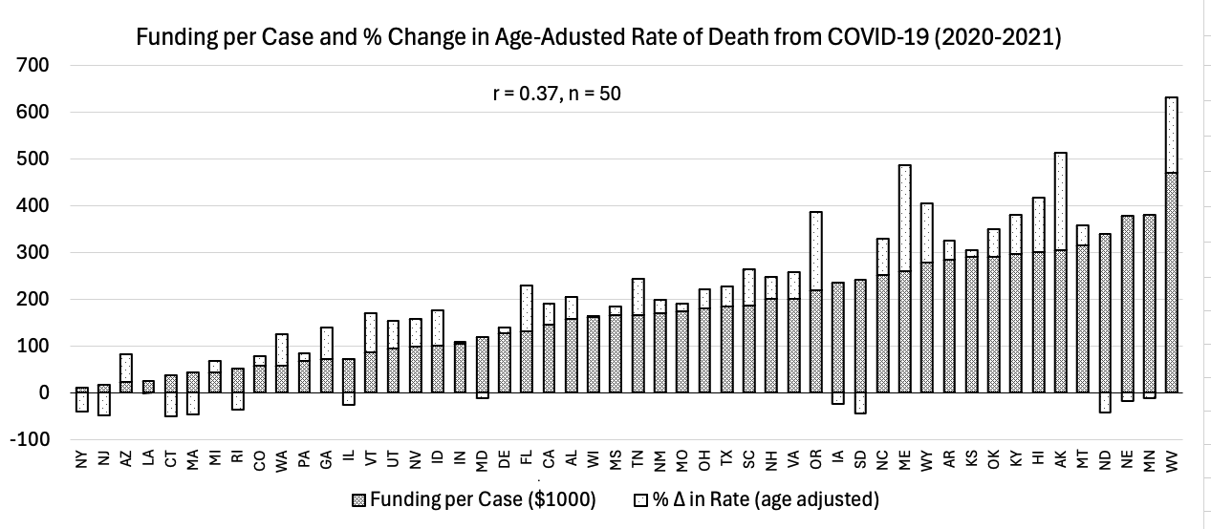
Fig.2: Graph generated from data published on Becker’s Hospital Review and the CDC Wonder website [1, 7].
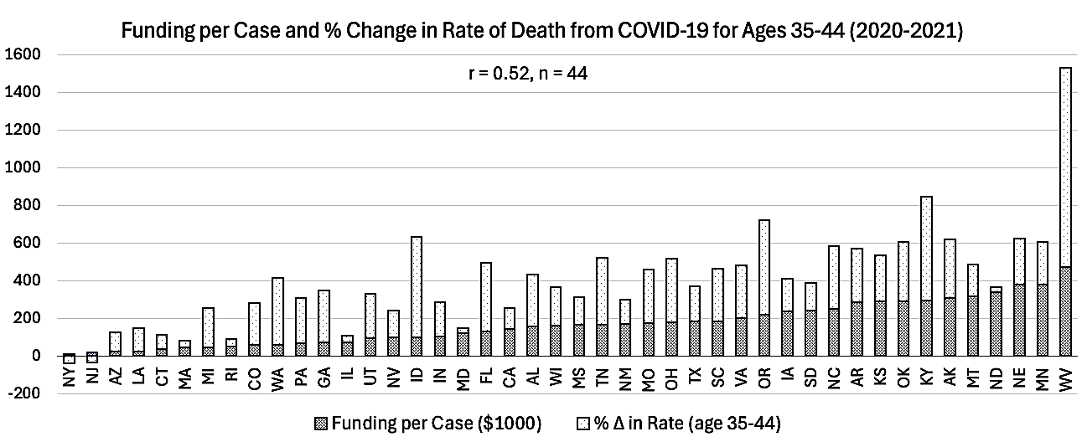

If this relationship is causal how might health institutions have accomplished this without raising red flags? Reports of road fatalities being attributed to COVID-19 (true or not) could not have played significant role in padding these numbers because this deception is too obvious [8]. The most credible and “morally justifiable” way to pad the COVID numbers is to conflate all cases with flu-like symptoms with COVID-19.
Pneumonia is the 6th leading cause of death in the US and usually about 80% of pneumonia deaths occur in Americans 65 and older. This condition is generated by a wide range of pathogens and often develops as the result of a secondary infection in patients with influenza (Fig. 3) and even though pneumonia mortality exceeds influenza by a 3-10 ratio during flu season, these deaths are strongly correlated (Fig. 4).
Fig.3: Graph generated from data published on the CDC Flu View Interactive website [9].
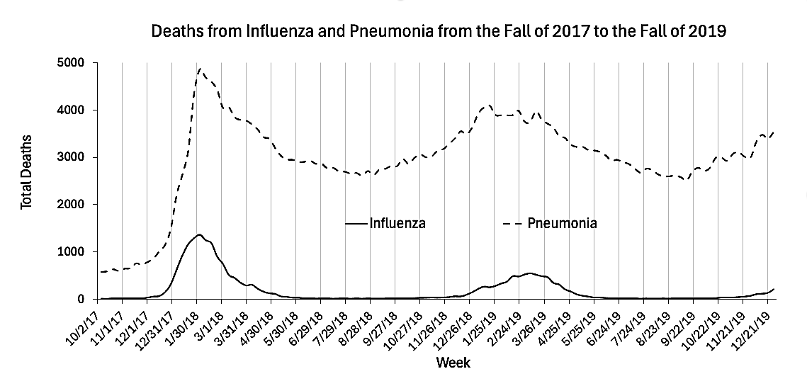
Fig.4: Graph generated from data published on the CDC Flu View Interactive website [9].
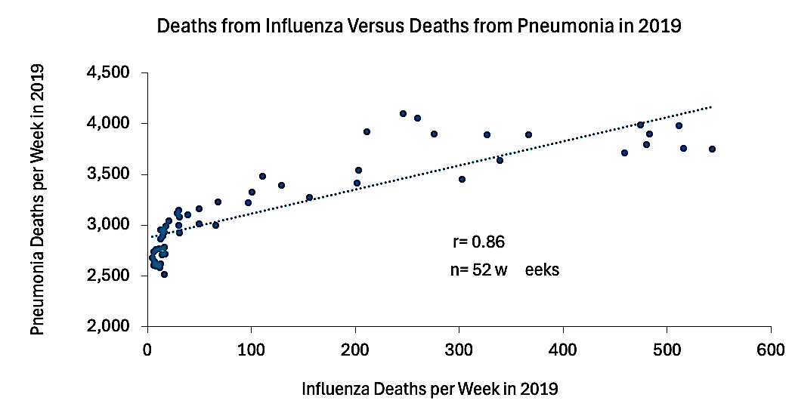

Annual deaths from influenza in the US declined 8,934 in 2020 to 1,107 in 2021 after it was allegedly “displaced” by COVID-19 [9, 10]. Unsurprisingly a large portion COVID patients succumbed to secondary pneumonia, but whereas pneumonia deaths always greatly outweighed deaths from influenza, deaths from COVID-19 matched and often exceeded deaths from pneumonia (Fig. 5). In addition, the near perfect correlation between these deaths implies that pneumonia played a role in most (and possibly all) deaths from COVID-19 (Fig. 6).

Fig.5: Graph generated from data published on the CDC Flu View Interactive website [9].
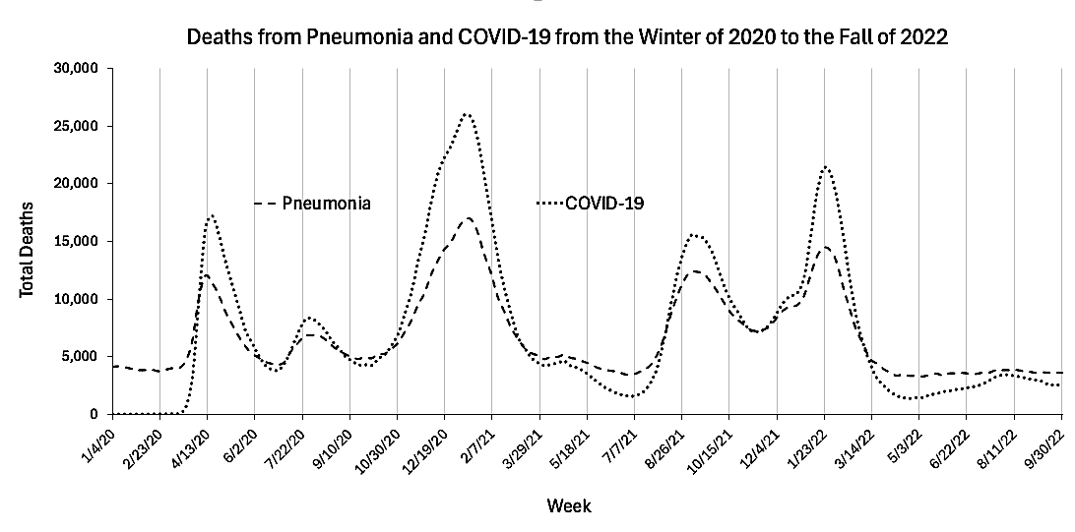
Fig.6: Graph generated from data published on the CDC Flu View Interactive website [9].
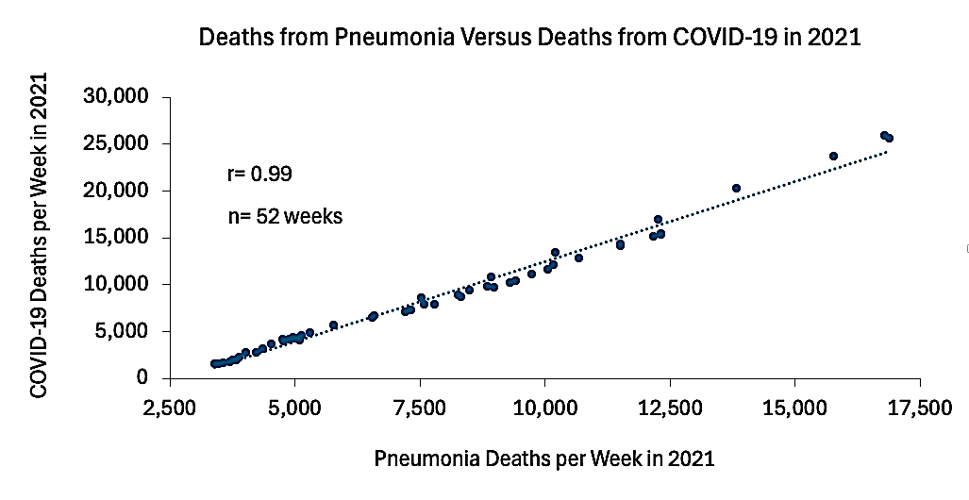

Regarding all deaths from COVID-19 as pneumonia-driven makes it easier to discern differences between the epidemiology of the novel virus and seasonal respiratory ailments of the “pre-COVID” era. If we compare pneumonia deaths from 2020 to 2022 with pneumonia deaths from 2019 serving as the pre-COVID baseline, we get five distinct peaks (Fig. 7). Peaks 1, 2, and 4 are particularly notable in that they all occur outside flu season and Peaks 2 and 4 affected significantly more Americans under the age of 65 (Fig. 8). Finally, health parameters compiled in 2018 are strongly correlated with pneumonia death rates per state in 2021. What are the implications?

First, pneumonia and COVID deaths under age 65 exceeded the baseline of 20% during Peaks 2 and 4 (Fig. 7 and 8). This is anomalous in two ways: First, because these peaks occur outside flu season. Second, because prior to the pandemic, pneumonia deaths for under age 65 remained consistently near the 20% baseline throughout the year (data not shown) [9]. It is also notable that both of these anomalous peaks only occur after Act payments had already been distributed to the states in April of 2020 [1, 2, 3]. This timing concurs with the allegations of CARES payments incentivizing hospitals to inflate their COVID numbers.

Second, deaths from pneumonia under age 65 returned and then remained near the baseline low of 20 percent shortly after the start of 2022. Then by the end of April, COVID-19 started to play less of a role in deaths from pneumonia (Fig. 8). This timing also concurs with the aforementioned allegations because CARES expired on March 27, 2022 [11].

Third, death rates from pneumonia in 2021 are strongly correlated with pre-existing health conditions reported in 2018 (Fig. 9). In fact, the correlation coefficient increases to -0.84 when comparing 2021 death rates from COVID-19 with the same pre-existing conditions (graph not shown). Since the weak and immunocompromised are most likely to die from pneumonia, these relationships on their own do not seem to reveal anything new, but when the same pre-existing conditions are comparted to pre-COVID pneumonia death rates in 2019, the correlation coefficient drops to -0.37 (graph not shown). This timing also concurs with the aforementioned allegations because (unless COVID-19 is simply more “efficient” at culling the weak) CARES payments could have incentivized hospitals to attribute a wider range of pre-existing conditions to COVID-19.

Fig.7: Graph generated from data published on the CDC Flu View Interactive website [9].
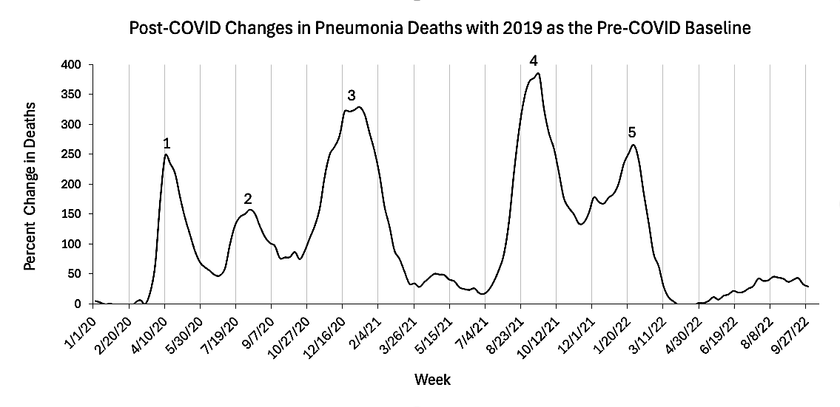

Fig.8: Graph generated from data published on the CDC Flu View Interactive website [9].
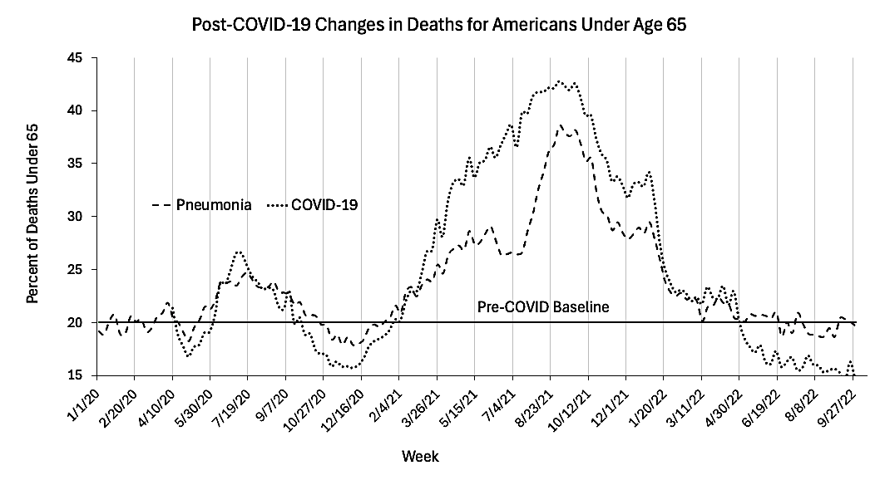

Fig.9: Graph generated from data published on the CDC Flu View Interactive website and the United Health Foundation [9, 12].
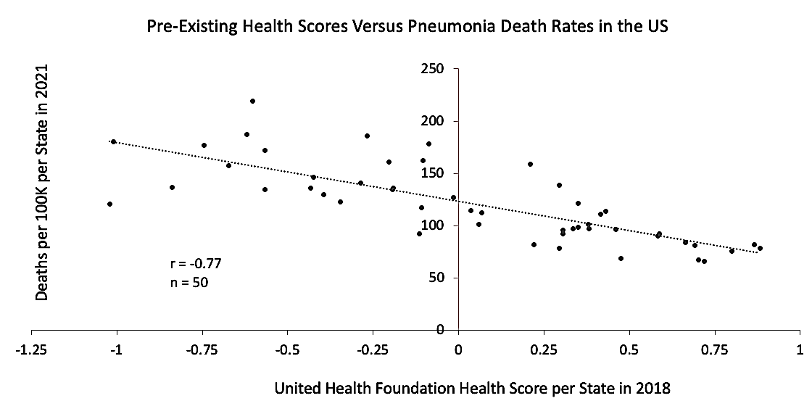

After CARES payments were distributed in 2020, health care officials in states most affected during the “first wave” complained that Health and Human Services had allocated “a chunk of money without particular regard for who has been hardest hit”. The robust inverse correlation between payments and the initial off-season peak of 2020 appears to validate these allegations (Fig. 10).

Fig.10: Graph generated from data published on Becker’s Hospital Review and the CDC Flu View Interactive website [1, 9].
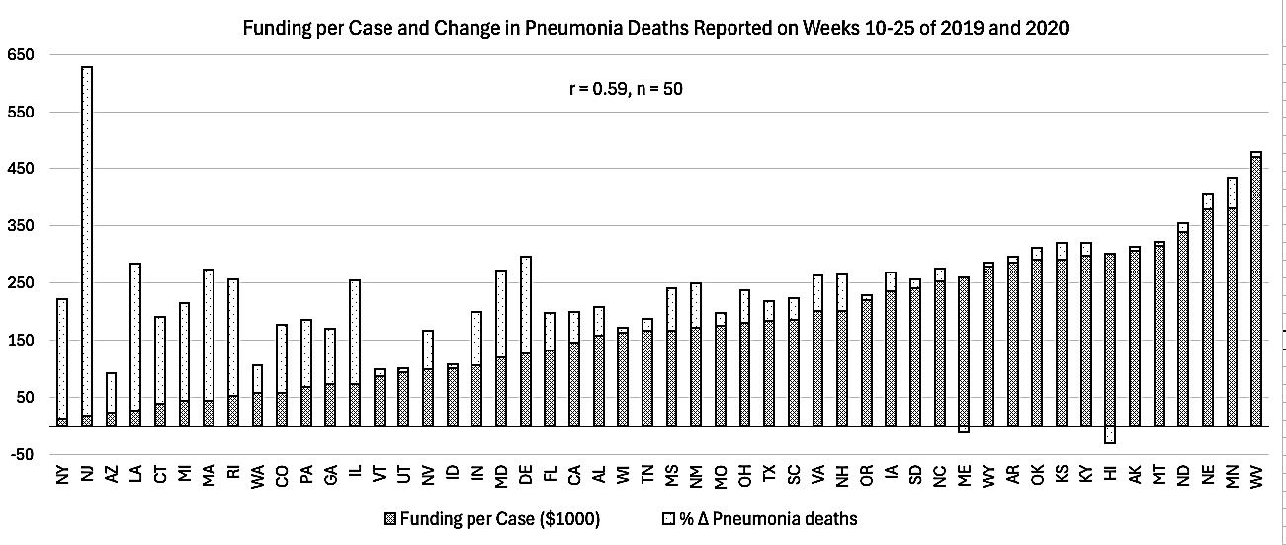

The virulence of SARS-Cov-2 is debatable, but beyond dispute are surges in all-cause mortality that occurred under harsh countermeasure implemented in the following reports that the novel had arrived in the US in 2020 (Fig. 11A and 11B).

Social Security data on risk of dying by age group sheds light on an unexpected pattern whereby younger Americans were far more impacted than senior citizens during the pandemic. In fact, during the “deadliest year” of COVID-19 (2021), the death rate for ages 75 and higher slightly declined from its highest point in 2020. Why did death rates surge by 35-45% in 2021 for both men and women ages 25-55? Why was the “surge” for ages 75 and up so minimal, peaking at only 10-17% in 2020?

Data from the CDC indicates that the 2020-2021 surge death rates in the younger cohort was driven largely by drugs (mostly opioids) because overdose deaths in these age groups surged after pandemic-related countermeasures were enforced during the spring of 2020 (Fig. 12) [13]. Could overdose deaths have also played a credible role in padding the numbers of young people dying of COVID/pneumonia during the off-season pneumonia peaks that occurred after April of 2020 (Fig. 7 and 8)? Is this responsible for the stronger correlation between CARES payments and COVID deaths for ages 35-44 (Fig. 2)? Is this also why 5-year cohorts from ages 20-44 are more strongly correlated to CARES payments than 5-year cohorts from ages 45-84 (Table 1)? The plausibility of this scenario is laid out in the discussion.

Fig.11A and 11B: Graphs generated from data published on the US Social Security Administration website [14].
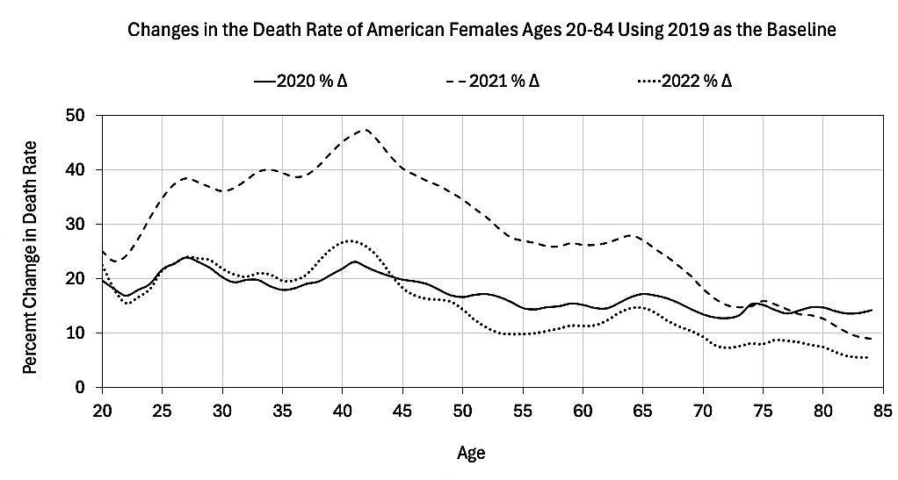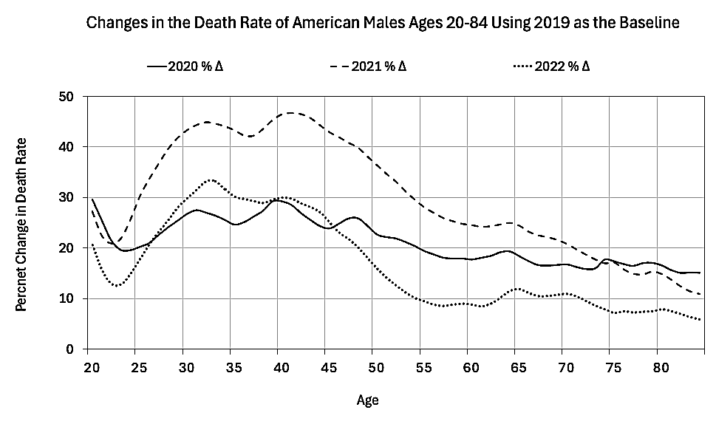
A

B

Fig.12: Graph generated from data published on the CDC Wonder website [7].
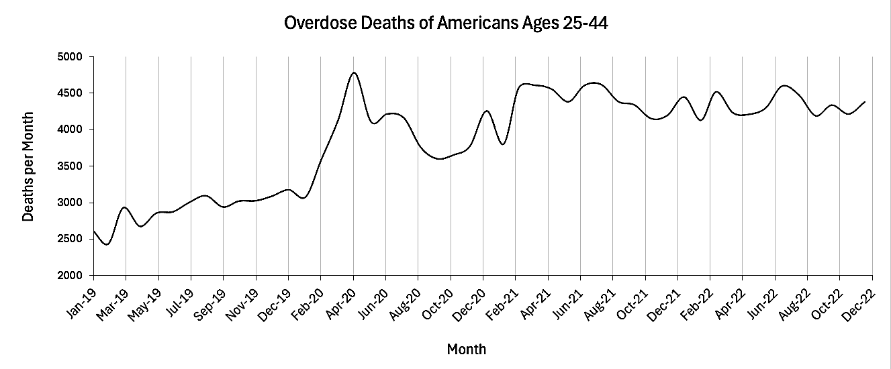

Table 1: Table generated from data published on Becker’s Hospital Review and the CDC Wonder website [1, 7].
Age | Correlation between CARES payments and % ∆ in COVID deaths 2020-2021 | Number of states | Mean and standard error for ages 20-44 and 45-84 (T-test p < 0.001)
20-24 | r = 0.45 | n = 10 | 0.49 ± 0.032  n = 5
25-29 | r = 0.56 | n = 22 | 0.49 ± 0.032  n = 5
30-34 | r = 0.49 | n = 29 | 0.49 ± 0.032  n = 5
35-39 | r = 0.40 | n = 35 | 0.49 ± 0.032  n = 5
40-44 | r = 0.57 | n = 36 | 0.49 ± 0.032  n = 5
45-49 | r = 0.36 | n = 44 | 0.36 ± 0.015  n = 8
50-54 | r = 0.33 | n = 45 | 0.36 ± 0.015  n = 8
55-59 | r = 0.42 | n = 47 | 0.36 ± 0.015  n = 8
60-64 | r = 0.37 | n = 49 | 0.36 ± 0.015  n = 8
65-69 | r = 0.40 | n = 49 | 0.36 ± 0.015  n = 8
70-74 | r = 0.39 | n = 50 | 0.36 ± 0.015  n = 8
75-79 | r = 0.36 | n = 50 | 0.36 ± 0.015  n = 8
80-84 | r = 0.29 | n = 50 | 0.36 ± 0.015  n = 8

Discussion:
Pulmonary complications are among the most frequently reported adverse events linked to opioid overdose and “aspirational pneumonia” plays a major role in these events. Opioid-induced aspiration is the result of four major mechanisms also linked to opioids; they are vomiting, delayed gastric emptying, reduction of the cough reflex, and lack of consciousness [15]. A histopathological study in Italy found evidence of “acute bronchitis and/or pneumonia” in 12% of the victims (n = 851) and a retrospective analysis in Austria found that 42% of opioid fatalities (n = 234) involved aspiration of gastric contents [15, 16].

Naloxone (brand name “Narcan”) is the standard emergency antidote for treating overdose victims in the US, and a study in Pittsburg based on 1,831 opioid overdose emergency admissions found that 62% of patients who were pre-treated with the maximum recommended dose of naloxone (4.4 mg) were 66% more likely to end up with pulmonary complications [17]. According to the authors; “…changing patterns of opioid usage, as well as the dissemination of naloxone to non-EMS personnel, have created a new paradigm for treating of opioid overdose in which increased dosage of naloxone has become the norm” [17]. If high doses of naloxone increase the rate of pulmonary complications, what is an “ideal dose” that accounts for the tradeoff between death from naloxone-induced pneumonia versus death from respiratory arrest (due to insufficient dosage)?

Naloxone was first made available to drug users in the 1990’s but it was not until 2017 that laws were passed to improve layperson access to Narcan [18]. Another finding of the Pittsburg study was an additional association between pulmonary complications and intranasal application of naloxone [17]. This detail is important because this method of application is more attractive to bystanders with little or no training.

From 2020 to 2021, the ratio between overdose and COVID-19 deaths for ages 35-44 dropped from 3.9:1 to 1.7:1 (23,497/6,079 versus 29,771/16,006) [7]. Did wider use of bystander-applied naloxone during the overdose surge of 2021 increase the number of pneumonia cases that in turn, served to cut in half the overdose/COVID fatality ratio in ages 35-44? Did CARES financial incentives persuade hospitals to associate a wider share of these pneumonia cases with COVID19? Only a re-examination of hospital records and death certificates might answer these questions.

HHS has emphasized that recipients may use PRF payments to cover incremental expenses attributable to COVID-19, suggesting that providers should not use PRF payments to cover expenses that would have been incurred if not for the pandemic.
https://www.medicaleconomics.com/view/cares-act-compliance-for-physicians-the-provider-relief-fund-explained

For many hospital systems, these payments offset a sharp drop in income caused by the cancellation of elective procedures, which are typically their primary revenue source.
https://legalclarity.org/cares-act-healthcare-provisions-what-they-cover/

“Secondary bacterial infection of the lung (pneumonia) was extremely common in patients with COVID-19, affecting almost half the patients who required support from mechanical ventilation. …It may even exceed death rates from the viral infection itself… The scientists also found evidence that COVID-19 does not cause a “cytokine storm,” so often believed to cause death. …The importance of bacterial superinfection of the lung as a contributor to death in patients with COVID-19 has been underappreciated because most centers have not looked for it…”

The “cytokine storm” is a hyperinflammatory condition that is symptomatically identical to septic shock. Septic shock is a major killer of patients with hospital-acquired pneumonia.
https://medicalxpress.com/news/2023-05-covid-patients-wasnt-cytokine-storm.html

New drugs
https://www.jdsupra.com/legalnews/cms-hikes-payment-for-covid-19-19452/

Remdesivir
https://pubmed.ncbi.nlm.nih.gov/33340409/

Hi flow oxygen
https://www.medintensiva.org/en-pulmonary-toxicity-by-oxygen-covid-19-articulo-S2173572722000777

…The investigators found nearly half of patients with COVID-19 develop a secondary ventilator-associated bacterial pneumonia…Those who were cured of their secondary pneumonia were likely to live, while those whose pneumonia did not resolve were more likely to die…The study findings also negate the cytokine storm theory…
https://medicalxpress.com/news/2023-05-covid-patients-wasnt-cytokine-storm.html

References:

1. https://www.beckershospitalreview.com/finance/state-by-state-breakdown-of-federal-aid-per-covid-19-case/

2. https://www.beckershospitalreview.com/finance/rural-america-braces-for-covid-19-as-more-hospitals-close/

3. https://kffhealthnews.org/health-care-costs/furor-erupts-billions-going-to-hospitals-based-on-medicare-billings-not-covid-19/

4. https://fee.org/articles/physicians-say-hospitals-are-pressuring-er-docs-to-list-covid-19-on-death-certificates-here-s-why/

5. https://www.newsweek.com/downsides-financial-incentives-diagnose-covid-opinion-1776181

6. https://www.cdc.gov/nchs/data/dvs/blue_form.pdf

7. CDC Wonder [Internet]. Atlanta (GA): National Center for Health Statistics Mortality Data; [Reviewed 2026 May 12; cited 2026 May 15]. Available from: https://wonder.cdc.gov/vaers.html

8. https://cbs12.com/news/local/man-who-died-in-motorcycle-crash-counted-as-covid-19-death-in-florida-report

9. https://gis.cdc.gov/grasp/fluview/mortality.html

10. https://www.globalresearch.ca/why-flu-disappeared/5737357

11. https://www.mieb.uscourts.gov/news/expiration-coronavirus-aid-relief-and-economic-security-cares-act

12.https://assets.americashealthrankings.org/app/uploads/2018ahrannual_020419.pdf

13. https://www.cdc.gov/nchs/products/databriefs/db428.htm

14. Social Security Actuarial Life Table [Internet]. (USA): Social Security Administration; [cited 2026 February 15]; Available from:
https://www.ssa.gov/oact/STATS/table4c6.html
15. https://link.springer.com/article/10.1007/s00414-020-02412-y

16. https://pubmed.ncbi.nlm.nih.gov/15894841/

17. https://www.annemergmed.com/article/S0196-0644(19)30309-9/fulltext

18. https://link.springer.com/article/10.1186/s12954-019-0352-0

18.

- Our World in Data [Internet]. (UK): Dattani S., Rodés-Guirao L., Ritchie H., Ortiz-Ospina E., Roser M.; c2023. Life Expectancy; 2023 [cited 2026 May 20]; Available from: https://ourworldindata.org/life-expectancy
- Our World in Data [Internet]. (UK): Roser M.; c2020. Why is life expectancy in the US lower than in other rich countries?; 2020 [archived 2026 May 12; cited 2026 May 20] Available from: https://archive.ourworldindata.org/20260512-185716/us-life-expectancy-low.html
- Social Security Actuarial Life Table [Internet]. (USA): Social Security Administration; [cited 2026 February 15]; Available from:
https://www.ssa.gov/oact/STATS/table4c6.html
- Our World in Data Human Mortality Database – with minor processing by Our World in Data [Internet]. (UK): OurWorldinData.org; 2025; Central death rate at birth – HMD – period tables” [dataset]. Human Mortality Database, “Human Mortality Database” [original data]. [cited 2026 April 20] Available from:
https://ourworldindata.org/grapher/annual-death-rate-by-age-group?time=2006
- Devine J. Two states, a third of counties have more deaths than births [Internet]. (USA): US Census Bureau; [published 2017 October 24, cited 2026 February 15]; Available from:
https://www.census.gov/library/stories/2017/10/aging-boomers-deaths.html
- CDC [Internet]. Atlanta (GA): About Estimated Flu Burden [published 2026 February 25, cited 2026 May 15]; Available from: https://www.cdc.gov/flu-burden/php/about/index.html
- USA Facts [Internet]. (USA): How many people live in the US [updated 2026 March 4, cited 2026 April 15]; Available from: https://usafacts.org/answers/how-many-people-live-in-the-us/country/united-states/?endDate=2021-01-01&startDate=2010-01-01
- Our World in Data [Internet]. (UK): Deaths by age group, United States [cited 2026 April 15] UN, World Population Prospects [2024] – processed by Our World in Data. “Number of children who die before age 5 – UN WPP” [dataset]. United Nations, “World Population Prospects”; United Nations, “World Population Prospects - Interim Update” [original data]. Available from: https://ourworldindata.org/grapher/annual-deaths-by-age?time=2010&country=~USA
- CDC Wonder [Internet]. Atlanta (GA): National Center for Health Statistics Mortality Data; [Reviewed 2026 May 12; cited 2026 May 15]. Available from: https://wonder.cdc.gov/vaers.html
- Hedegaard H, Miniño A, Rose Spencer M, and Warner M. Drug Overdose Deaths in the United States, 1999–2020. NCHS [Internet]. 2021 December [cited 2026 April 15]; Data Brief No. 428. Available from: https://www.cdc.gov/nchs/products/databriefs/db428.htm
- World Population Review [Internet]. Lancaster (PA): Native American population by state 2026; [cited 2026 April 15]. Available from: Review. Retrieved from: https://worldpopulationreview.com/state-rankings/native-american-population
- CDC National Center for Health Statistics [Internet]. Atlanta (GA): U.S. Life Expectancy by State and Sex, 2018–2022; [cited 2026 April 15]. Available from: https://www.cdc.gov/nchs/data-visualization/state-life-expectancy/2022.htm?Total=Total
- Tavernise S. Life expectancy for white Americans drops sightly; analysts cite drug overdoses. New York Times. 2016 April 20.
- Tavernise S, Goodnough A. Life expectancy of Americans rises for first time in four years. New York Times. 2020 January 30.
- Katz J, Sanger-Katz M. It’s Huge, ‘It’s Historic, It’s Unheard-of’: Drug Overdose. New York Times. 2021 July 14.
- Shmerling R. Why life expectancy in the US is falling: COVID-19 and drug overdoses are the biggest contributors. 2022 October 20. Harvard Health Publishing. Available from:
https://www.health.harvard.edu/blog/why-life-expectancy-in-the-us-is-falling-202210202835
- Mahr K. Covid-19 and overdose deaths drive U.S. life expectancy to a 25-year low. Politico. 2022 December 22. Available from:
https://www.politico.com/news/2022/12/22/covid-19-and-overdose-deaths-drive-u-s-life-expectancy-to-a-25-year-low-00075081
- Daley J. Colorado sees a drop in life expectancy not seen since WWII, driven by COVID and overdose deaths. Colorado Public Radio News. 2022 June 25. Available from: https://www.cpr.org/2022/06/25/colorado-life-expectancy-falls-covid-overdose-deaths
- US Senate Committee on Homeland Security & Governmental Affairs. Testimony of Pierre Kory, MD Homeland Security Committee Meeting: Focus on Early Treatment of COVID-19. 2020 December 8. Available from:
https://www.hsgac.senate.gov/wp-content/uploads/imo/media/doc/Testimony-Kory-2020-12-08.pdf
- Kory P, Pfeiffer M. More young Americans are dying – and it's not COVID. Why aren't we searching for answers? USA Today. 2023 August 11. Available from:
https://www.usatoday.com/story/opinion/2023/08/11/more-americans-dying-than-before-pandemic-covid-deaths/70542423007/
- Capuzzo M. 5 Takeaways from Washington Post’s investigation into chronic disease and decline in U.S. life expectancy. The Defender. 2023 October 11, 2023. Available from:
https://childrenshealthdefense.org/defender/washington-post-life-expectancy-covid-vaccines/
- Jimmy Dore Show; Young people are dying at staggering rates! w/ Dr. Pierre Kory. Interview recording. 2024 January 23. Available from: https://rumble.com/v48tlk6-young-people-are-dying-at-staggering-rates-w-dr.-pierre-kory.html
- CDC Wonder [Internet]. Atlanta (GA): Vaccine Adverse Event Reporting System; [Reviewed 2026 May 12; cited 2026 May 15]. Available from: https://wonder.cdc.gov/vaers.html
- CDC [Internet]. Atlanta (GA): Provisional Drug Overdose Death Counts [Reviewed 2026 May 13; cited 2026 May 30]. Available from: https://www.cdc.gov/nchs/nvss/vsrr/drug-overdose-data.htm
- The National World War II Museum [Internet]. New Orleans (LA): Research Starters: Worldwide Deaths in World War II. [cited 2026 May 30]. Available from:
https://www.nationalww2museum.org/students-teachers/student-resources/research-starters/research-starters-worldwide-deaths-world-war
- Electronic Records Reference Report from the National Archives [Internet]. College Park (MD): Vietnam War U.S. Military Fatal Casualty Statistics. [Reviewed 2022 August 22; cited 2026 May 30]. Available from:
https://www.archives.gov/research/military/vietnam-war/casualty-statistics

