4.3) Worldwide Risk Factors and Health Outcomes
Objective: This data-gathering exercise highlights the major health issues in the developing world and allows you to weigh the importance of corresponding risk factors and policies with regards to specific health outcomes.
Video Instructions: https://vimeo.com/472642519 Note: Due to major re-organizing most of the navigation instructions in the video are obsolete, but these instructions are useful for learning how to download the data in spreadsheet format and remove the unneeded columns and rows from the spreadsheet.

Part A: Interpreting Charts and Color-Coded Maps
- Road Safety (chart):
  - Open the “Estimated road traffic death rate” link: https://www.who.int/data/gho/data/indicators/indicator-details/GHO/estimated-road-traffic-death-rate-(per-100-000-population)
  - Note regions with highest and lowest death rates from traffic accidents based on the chart.
  - Note where the US ranks for road safety.
- Indoor Air Pollution (map):
  - Open the “Household pollution attributable death rate (per 100,000 population, age standardized)” link:
https://www.who.int/data/gho/data/indicators/indicator-details/GHO/household-air-pollution-attributable-death-rate-(per-100-000-population-age-standardized)
  - Note regions and nations with highest death rates from indoor air pollution based on the color-coded map.
  - Open the “Proportion of population with primary reliance on polluting fuels and technologies for cooking (%)” link: https://www.who.int/data/gho/data/indicators/indicator-details/GHO/gho-phe-population-with-primary-reliance-on-polluting-fuels-and-technologies-for-cooking-proportion
  - Note regions and nations with the highest percentages on the color coded map.
Part B: Spreadsheets
- Obesity:
  - Open the “Prevalence of obesity among adults, BMI >=30 (age-standardized estimate) (%)” link:
https://www.who.int/data/gho/data/indicators/indicator-details/GHO/prevalence-of-obesity-among-adults-bmi-=-30-(age-standardized-estimate)-(-)
  - This will take you to the map. Open the symbol for “Data (Fig. 1).”
  - To narrow down, click on “Filter” (Fig. 2) and choose “Latest” for the year and “Both Sexes” for the sex. Click “Apply (Fig. 3).” This provides the most recent data (Fig. 4).

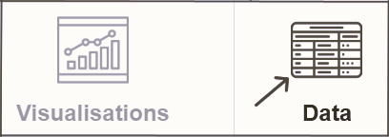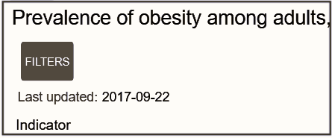
Fig. 1 Fig. 2

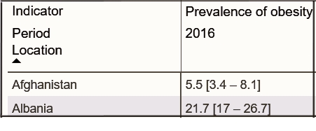
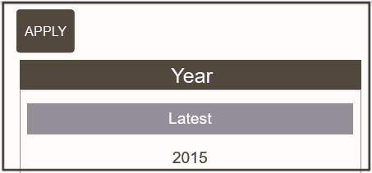
Fig. 3 Fig. 4

  - Follow the website instructions to download the data into an Excel spreadsheet.
  - Use the sorted data to find nations with obesity rates of 40% or higher.

- Suicide:
Go to this website and note down which nations have the 10 highest suicide rates:
https://worldpopulationreview.com/country-rankings/suicide-rate-by-country

- Gender Differences in Life Expectancy:
Copy the data from this website into a spreadsheet and follow the instructions for calculating gender differences: https://www.worldometers.info/demographics/life-expectancy/
  - Enter this equation for subtracting male from female life expectancy (Fig. 8).
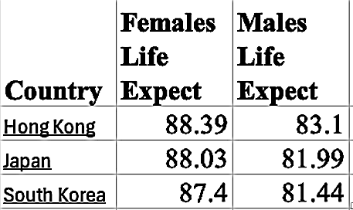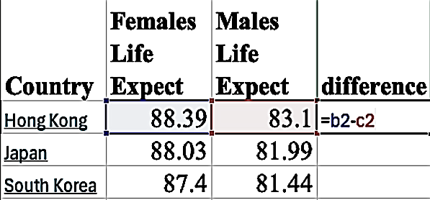
Fig. 7 Fig. 8

  - Use the “sort” function to arrange the data in order of life expectancy differences between male and female.
  - Use the sorted data to find nations with the largest gender differences in life expectancy (usually > 10 years).

- Progress in Life Expectancy from 1900-present:
Go this website: https://www.worldometers.info/demographics/life-expectancy/
- Set the time period from 1900 to the present.
- Mark off the boxes to include the following nations in your graph: US, China, Japan, Nigeria, Rwanda, and Zimbabwe.
- Download the graph you generated.

Pre-Lab questions:
- List 1-2 nations or territories where you expect to see the highest traffic fatality rates.
- List 1-2 nations or territories where you expect to see the highest rates of indoor air pollution.
- List 1-2 nations or territories where you expect to see the highest rates of obesity
- List 1-2 nations or territories where you expect to see the highest rates of suicide.

Post-Lab questions:
- Which region has the highest traffic fatality rate?

- Which region has the highest rate of indoor air pollution?

- Does this match the death rate from indoor air pollution?

- What generates this pollution?

- Which region has the highest rate of obesity? Name one of these nations:

- Which five nations have the highest suicide rates?

- Which region has the biggest difference in life expectancy between men and women? Name one of these nations:

- What is responsible for this difference?

- Why did life expectancy in the US decline around 1918?

- Why did life expectancy in the Japan decline 1940-1950?

- Why did life expectancy in the China decline around 1960?

- Why did life expectancy in the Rwanda decline in the mid 1990’s?

Assignment Checklist:
- Did you completely answer pre-lab and post-lab questions?
- Did you enter the life expectancy data into a spreadsheet and sort by gender difference?
- Did you upload the graph on life expectancy in different nations from 1900 to the present?

4.3) Instructor’s Guide to Worldwide Risk Factors and Health Outcomes
Overview: This activity provide opportunities for discussion on health problems and environmental challenges unique to other nations, so plan accordingly. The chart below is what students should get when looking at life expectancy in these 6 nations from 1900 to the present.
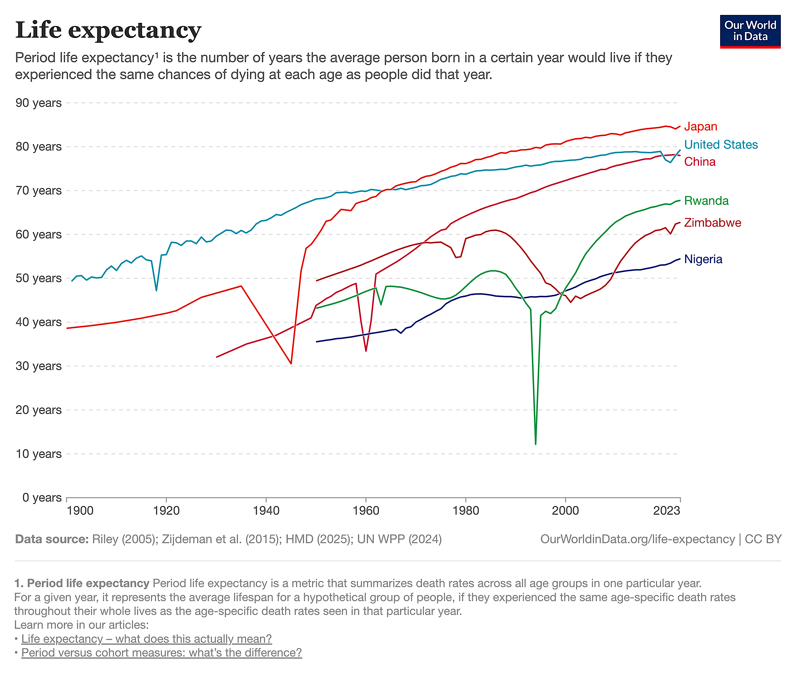

Answers to Questions: 1) Africa has the highest traffic fatality rate. 2) Mostly African nations have the highest death rate from indoor pollution. 3) Yes. 4) Wood burning stoves. 5) Pacific islanders have highest obesity rates. 6) Greenland, Suriname, South Korea, Guyana, and Lithuania have the highest suicide rates. 7) Russian and Eastern Europe have highest gender differences in life expectancy. 8) This is most likely caused by alcohol consumption. 9) This is the time of the “Spanish flu”. 10) This is the during the time period of Japan’s participation and recovery from World War II. 11) This happened during a famine in China associated with the “Great Leap Forward”. 12) This coincides with a nationwide massacre of Tutsi’s in Rwanda by Hutu militants.
Logistics: Websites often get reorganized or taken down, so you should try this activity yourself before giving these instructions to your students.
Degree of Difficulty: 2—Some students may feel overwhelmed and intimidated by the clutter of lengthy titles and footnotes in the raw data sample. You will need to try this on your own so that you can provide the proper guidance on how to rearrange and clean up the data. Not all students might be proficient with spreadsheets, so you may want to teach a few key students how to make scatter plots. These students can in turn teach everyone else.
4.4) U.S. Risk Factors and Health Outcomes
Objective: This data-gathering exercise highlights the major health issues in the developed world and allows you to look for correlation between risk factors to health outcomes.
Video instructions: https://vimeo.com/836251081 and https://rumble.com/v73mnha-downloading-us-health-parameters-and-risk-factors-into-a-spreadsheet.html?e9s=src_v1_ucp_a

Risk Factor Data Collection and Spreadsheet Creation:
- For smoking rates: https://www.lung.org/research/trends-in-lung-disease/tobacco-trends-brief/data-tables/ad-cig-smoking-state
- For obesity rates: https://www.cdc.gov/obesity/data-and-statistics/adult-obesity-prevalence-maps.html
- For hypertension rates: https://www.cdc.gov/nchs/state-stats/deaths/hypertension.html
- For diabetes rates: https://gis.cdc.gov/grasp/diabetes/diabetesatlas-surveillance.html#
- For heart disease rates: https://www.cdc.gov/nchs/state-stats/deaths/heart-disease.html
- For exercise rates: https://www.valuepenguin.com/fittest-and-least-fit-states
- For cancer rates: https://wonder.cdc.gov/cancer-v2022.html
- Copy and paste all data columns into one spreadsheet (Fig. 1) and make sure the states in all the columns line up from top to bottom.
- Remove unnecessary columns (Fig. 2).
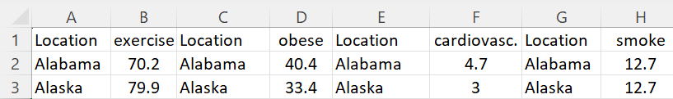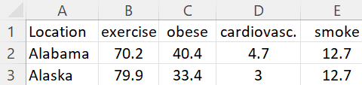
Fig. 1 Fig. 2
- Follow the video instructions provided by your instructor to generate following five graphs:
  - Physical Activity versus Obesity Rate
  - Physical Activity versus Cardiovascular Disease
  - Smoking versus Cardiovascular Disease
  - Smoking versus Lung Cancer
  - Smoking versus Obesity
- Generate two more graphs that are not on this list.

Cancer Outcomes in the U.S.:
- Go to the CDC Wonder interactive website: https://wonder.cdc.gov/
- Scroll down and open “Cancer Statistics.”
- Under “Cancer Incidence 1999-2019,” open the “Data Request.”
- In Box 1 (Organize Table Layout), choose “States” and “Age-Adjusted Rates.”
- In Box 4 (Table Layout), choose “Lung and Bronchus.”
- Scroll to the bottom and click on “Send.”
- Follow the instructions provided by your instructor to copy and paste lung cancer rates into your spreadsheet (Fig. 3) and use this to create a graph on smoking versus lung cancer.
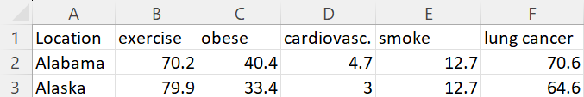
Fig. 3
- Go back to the previous page to create a new chart.
- In Box 1, choose “Race” and “Age-Adjusted Rates.”
- Do five separate searches based on the following four options in Box 4:
  - Melanoma of the Skin
  - Myeloma
  - Prostate
  - Female Breast
  - Liver
- Record all race-based cancer rates to the chart:
Cancer Rates
 | Melanoma | Myeloma | Prostate | Fem. Breast | Liver
Asian or Pacific Is.
Black or Afr. Amer.
White

Vaccine Adverse Event Reporting:
- Go to the CDC Wonder interactive website: https://wonder.cdc.gov/
- Scroll down and open “Vaccine Adverse Event Reporting.”
- Click on the link acknowledging that you read the disclaimer to enter the Vaccine Adverse Event Reporting System.
- Open “VAERS Data Search.”
- In Box 1 (Organize table layout), choose “Year of Onset.”
- In Box 5 (Select other event characteristics), choose “Death.”
- Scroll to the bottom and click on “Send.”
- Record numbers of reported deaths to the table under “Deaths at all ages.”
- Go back to the previous page to do a new search.
- For Box 1, choose “Year of Onset.” For Box 5, choose “Congenital anomaly/Birth Defect,” and click “Send.”
- Record numbers of reported birth defects to the table under “Birth Defects.”
- Go back to the previous page to do a new search.
- For Box 1, choose “Year of Onset.” For Box 4 (Select location, age, gender) choose both “<6 months” and “6-11 months.” For Box 5, choose “death,” and click “Send.”
- Record numbers of vaccine-caused deaths to the table under “Deaths for <1 year old.”
Adverse Events Reported to VAERS
 | 2015 | 2016 | 2017 | 2018 | 2019 | 2020 | 2021
Deaths at all ages
Birth Defects
Deaths for < 1 year old

Questions:
- Based on your graphs, is there any correlation that probably does not demonstrate a direct cause and effect? If yes, what is the third variable that might be responsible for the correlation between x and y?

- Which cancer or cancers disproportionately affect the following groups:
  - Asian/Pacific Islander
  - Black/African American
  - White

- Why is it necessary to check the box for “age adjusted”? What is the problem with not adjusting for age while collecting data for a chronic condition like heart disease or cancer?

- Divide total reports of vaccine-attributed deaths reported in 2021 by the average number of deaths reported from 2015-2019. Show work:

- What is responsible for the sudden increase in reports of vaccine-attributed deaths in 2021?

- Did reports vaccine-attributed birth defects increase during the same time period?

- Did reports of vaccine-attributed deaths increase for babies vaccinated during the same time period?

- Why is the trend different for babies vaccinated during this time period?

Assignment Checklist:
- Did you complete all 5 graphs?
- Are the graphs presented in a text file (like word, pages, or pdf)?
- Did you answer all the questions?

4.4) Instructor’s Guide to U.S. Risk Factors and Health Outcomes

Overview: Puerto Rico, Guam, and the Virgin Islands often show up as outliers with the rest of the U.S. If you choose not to delete them, you may consider using them as the basis for discussing why they are outliers. The graph below excludes Guam and the Virgin Islands, but does include Puerto Rico, which is the outlier in the left of the line. This implies that Puerto Rico has a lower than predicted rate of cardiovascular disease.
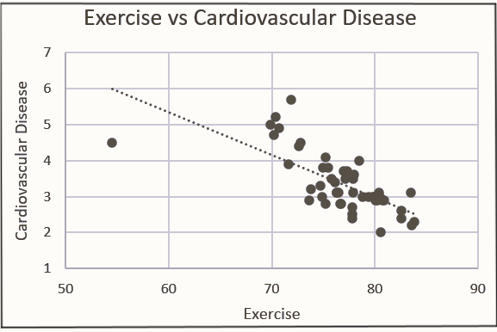

Cancer Rates
 | Melanoma | Myeloma | Prostate | Fem. Breast | Liver
Asian or Pacific Is. | 1.4 | 3.8 | 70 | 92 | 12.1
Black or Afr. Amer. | 1.0 | 12.9 | 209 | 122 | 8.6
White | 23.2 | 5.8 | 127 | 128 | 5.6

Answers to Questions: 1) There is no evidence that smoking causes obesity. This correlation might be attributed to poor people being disproportionately represented among those who either smoke, are overweight, or both. 2) Asians: liver cancer, Blacks: myeloma and prostate cancers, Whites: melanoma 3) Chronic conditions are more likely to be overrepresented in states with more elderly people if you fail to compensate for age. 4) Reports of vaccine-attributed deaths increased 135X in 2021. 5) COVID vaccines became available in 2021. 6) Yes. 7) No. 8) Babies were not vaccinated for COVID in 2021.
Logistics: These websites involve different pathways to the data, so you should navigate them on your own before you give the instructions to your students so that you can answer their questions and make revisions to the instructions in the event that changes are made to the websites. If your students are not up to the task of gathering all the data themselves, you may provide it to them ready-made from the file on your disk and let them use it to make graphs. I do not recommend doing this unless students spend some time navigating the CDC website so they at least become familiar with the website. Make sure to delete all graphs on “sheet 2” of the file in the event you choose to provide it to your students.
Degree of Difficulty: 2—Not all students might be proficient with spreadsheets, so you may want to teach a few key students how to make scatter plots. These students can in turn teach everyone else.

